**Dental Clinic Services System**

Final progress

Software Design

By

**Kanokwan Maneerat 542115002**

**Worapun Wongkium 542115055**

Department of Software Engineering

College of Arts, Media, and Technology

Chiang Mai University

Project Adviser

______________________________

Miss Pattama Longani

**Software Design**

**Revision Table**

|  |  |  |  |  |  |
| --- | --- | --- | --- | --- | --- |
| **Document Name** | **Detail** | **Status** | **Date** | **Viewable** | **Reviewer& Responsible** |
| DCSS – SDD – v 0.1 | Add all document | Draft | 30/11/2014 | Adviser | Kanokwan & Worapun |
| DCSS – SDD – v 0.2 | Edit class diagram and class diagram description | Draft | 10/12/2014 | Adviser | Kanokwan & Worapun |
| DCSS – SDD – v 1.0 | Double check all document | Realease | 11/12/2014 | Adviser | Kanokwan & Worapun |

Table of Contents

Chapter One: Introduction 4

1. Introduction 4

1.1 Objectives 4

1.2 Project Scope 4

1.3 User Classes and Characteristics 5

# 

# Chapter One: Introduction

## 1. Introduction

## 1.1 Objectives

Dental clinic service system consists of a web application and a mobile application which supports iOS7. The system supports English language for people who are patients, officers, or dentists of dental clinics. Furthermore, it offers some features for visitors who would like to gain information about the clinic. This system will reduce officers’ work and help patients save their time. Patients can find information about the dental clinic and personal information using the mobile application as well as the web application. For the visitor who wants to have a dental treatment from the clinic, and the dentist can use the system for checking their appointment schedule. Dental clinic services system integrates the services that are provided by most dental clinics into the web application and the mobile application. By combining all the services into one, the system provides more convenience to dental clinic users as well as staff.

This Software Design has described in more detail of each design of system and each function flow that the system should do. The document includes the Scope of project, Product function, User characteristic, System architecture, Detail design, Sequence diagram, and User interface design.

## 1.2 Project Scope

The objective of this software design is to specify the requirements that the system should fulfill, which are as follows:

* Dental clinic services system provides an application that is accessible via web browser on a computer and also on a mobile phone.
* Dental clinic services system on mobile phone support iOS.
* Dental clinic services system supports English language only.
* Dental clinic services system provides features for dental clinics’ registered user whose are patients, officers and dentists.
* Dental clinic services system assists managing appointments of patients and dentists using the web application and the mobile application.
* Dental clinic services system provides a user authentication for each patient and dentist through dental clinic officers.
* Dental clinic services system provide features for generate QR code to patients from both web application and mobile application
* Dental clinic services system provide features for managing the queue of dental clinic
* Dental clinic services system assists following up treatment between dentist and patient
* Dental clinic services system provide the feature for promoting the clinic also managing those promotion and information
* Dental clinic services system help visitor and patient to predict the cost of dental care

### 1.3 User Classes and Characteristics

The system divides users into 4 groups. Information and characteristics of each group are listed below.

* **Visitor**

This group of user no needs to register to the system to use the services on the website or to use their mobile phone. Visitor is able to:

* Visitor can view calendar from Google Calendar.
* Visitor can view dental clinic information and promotion
* Visitor can select dental treatment to estimate the cost
* **Patient**

This group of user needs to be registered to the system at the dental clinic. They will get patientID and password from the clinic to use the services on the website or to use their mobile phone. Patients use their patientID to login. Patients are able to:

* Patient can receive a pateintID and password from the dental clinic.
* Patient can login to the web application and the mobile application.
* Patient can logout from the web application and the mobile application.
* Patient can view his/her appointment in the patient schedule.
* Patient can view all appointments in the dental clinic schedule.
* Patient can view their QR code.
* Patient can view follow up question.
* Patient can answer to follow up question.
* Patient can view dental clinic information and promotion.
* Patient can select dental treatment to estimate the cost.
* Patient can identify him/herself by using the QR code
* **Officer**

This group of users has the highest privilege in the system. They are given access to management functions for maintaining the system. Officers are able to:

* Officer can login to the web application using officerID and password.
* Officer can logout from the web application.
* Officer can register for new patients and dentists.
* Officer can add an appointment into the dental clinic schedule.
* Officer can edit an appointment in the dental clinic schedule.
* Officer can delete an appointment in the dental clinic schedule.
* Officer can add patient to a queue and reset queue.
* Officer can add information and promotion into the website.

# 

# Chapter Two: Overall Description

## 2. Overall Description

## 2.1 Product Perspective

Dental clinic services system consists a mobile application on iOS and a web application. The system helps patients save their time to contact with the dental clinic by providing features such as making an appointment, viewing upcoming appointment, and getting cost estimation. It also helps dentists to follow up their patients and view/manage their appointment schedule. The system reduces work load of officers by providing them with features such as using QR code to identify patients at the clinic and managing appointments for patients and dentists. Dental clinic services system integrates the services that are frequently sought and commonly used by most dental clinics into the web application and the mobile application. By combining all the services into one, the system provides more convenience to dental clinic users as well as staff.

## 2.2 Product Features

The dental clinic services system offers seven features.

* Feature 1: Schedule management
* Feature 2: Appointment management
* Feature 3: User registration and authentication
* Feature 4: Patient identification using QR code
* Feature 5: Dental care consulting and following up
* Feature 6: A dental clinic information and promotion
* Feature 7: Cost estimation of dental treatments

Each of features will create a step-by-step suit by priority. In this progress we will develop Feature 4, 5, 6, and 7

## 2.3 Design and Implementation Constraints

**List of project constraints:**

* The application works only on iOS version7.
* The application requires the Internet connection.
* The application is available for the users who are already registered to the system and also people who are not. Some features are offered to the registered users only.

# Chapter Three: System Architecture

## 3. System Architecture

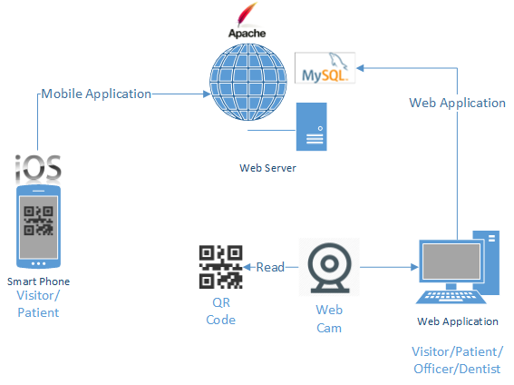

Figure 1: Shows the system architecture of Dental Clinic Services System

**Mobile Application for Smart Phone:** This part uses html language to create a hybrid mobile application from PhoneGap and PhoneGap Build. The application supports smart phones running on iOS only. User who does not login to the system are considered a ‘*Visitor*’. Visitor can view all appointments of the clinic, get cost estimation, view promotion and dental clinic information, and gain basic knowledge of dental treatment. User who uses a patientID and a password to login to the system is called ‘*Patient*’. Patient can view his/her appointment schedule, receive a QR Code that is used for user identification at the clinic, consult with dentists, and use all services provided for visitors.

**Web Application**: Web application can be used by all types of users (Patient, Officer, and Dentist). Patient can use all services provided by both the web application and the mobile application. Officer can use the web application to manage appointments, dentist accounts, patient accounts, and also manage all the data in web application and the mobile application. For example, officer can change the price in cost estimation function and change information of the dental clinic and dentists.

**Web Server:** Web server is the server that supports the services provided for the mobile application as well as the web application. It stores and provides the system data that is accessed via both the web application and the mobile application.

**QR Code and Web Cam:** QR Code is used to identify the patients at the clinic. Each QR Code contains a patientID for the web cam to read. Once the system retrieves the patient information from the QR Code, the information is used to look up the patient’s appointments and manage the waiting queue at the clinic. Web cam is used to read QR Codes.

## 3.1 Technologies used

### 3.1.1 Adobe® PhoneGap™ Build

Adobe® PhoneGap™ Build is an open-source frame work that allow us to upload html, css and javascript to build as a hybrid application for mobile phone. Adobe PhoneGap support many operating system such as iOS, Android, Windows Phone, webOS, Blackbery and more.

### 3.1.2 HTML5

HTML5 is markup language used for creating websites. Evolved from the HTML standard, HTML5 has more features such as working with MAP system, and creating a graphic without flash. It works with CSS and JavaScript and can be used not only to develop for the World Wide Web also but also to create mobile applications.

### 3.1.3 MySQL Server

MySQL Server is a Rational Database Management System(RDBMS) that stores data in separate tables. MySQL Server is an open source database that can be used in many different platforms and is very fast, reliable, scalable, and easy to use. It also provides a high performance, multi-threading, and multiuser rational database management.

### 3.1.4 Apache web server 2.5.10

Apache is a [public-domain](http://www.webopedia.com/TERM/P/public_domain_software.html) [open source](http://www.webopedia.com/TERM/O/open_source.html) [Web server](http://www.webopedia.com/TERM/W/Web_server.html) which provide a web page through the HTTP protocol. It is support in every operating system, including [Unix](http://en.wikipedia.org/wiki/Unix), [FreeBSD](http://en.wikipedia.org/wiki/FreeBSD), [Linux](http://en.wikipedia.org/wiki/Linux), [Solaris](http://en.wikipedia.org/wiki/Solaris_%28operating_system%29), [Novell NetWare](http://en.wikipedia.org/wiki/Novell_NetWare), [OS X](http://en.wikipedia.org/wiki/OS_X), [Microsoft Windows](http://en.wikipedia.org/wiki/Microsoft_Windows), [OS/2](http://en.wikipedia.org/wiki/OS/2), [TPF](http://en.wikipedia.org/wiki/Transaction_Processing_Facility), [OpenVMS](http://en.wikipedia.org/wiki/OpenVMS) and [eComStation](http://en.wikipedia.org/wiki/EComStation).

### 3.1.5 CodeIgniter 2.1.4

CaodeIgniter is a free and open source web application framework created in PHP language. CodeIgniter is designed based on Model-View-Controller(MVC) It works with PHP version 4 and 5, and makes it easier to use CRUD for any databases such as MySQL, Postgress, and SqlServer.

# Chapter Four: Detail Design

## 4. Detail Design

MVC(Model-View-Controller) is one of design pattern. MVC divides the structure of the system into three parts, which are model, view, and controller.

* Model is the form that is used to work with database
* View is the form that brings data from the models and display it in the user interface
* Controller is the form that collects user input and processes it. It also coordinates the view and the model to work together.

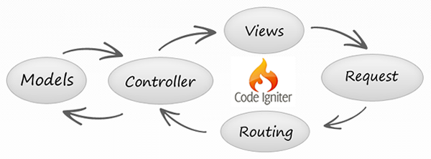

Figure 2: Shows the MVC pattern by using CodeIgniter

## 4.1 Class diagram

### 4.1.1 DCSS website class diagram

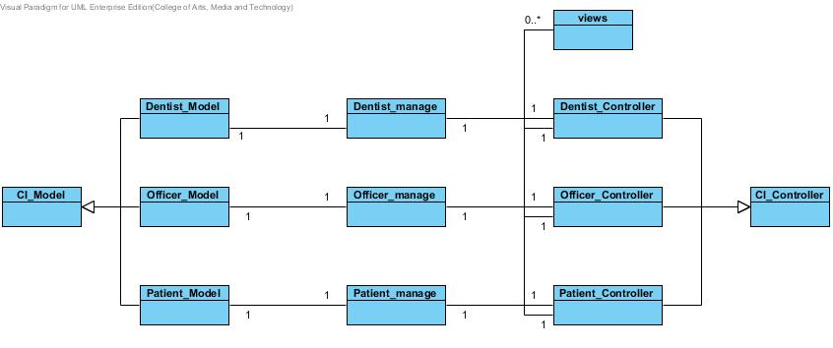

Figure 3: Shows class diagram of Dental Clinic Services System

### 4.1.2 DCSS mobile application class diagram

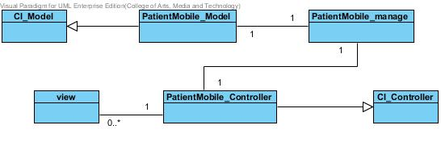

Figure 4: Shows class diagram of Dental Clinic Services System in mobile application

## **4.2 Class Diagram Description**

### **4.2.1 Class Diagram Description (DCSS website)**

CD-01, Class name: Dentist_Model

|  |  |  |  |
| --- | --- | --- | --- |
| ID | Name | Description | Remark |
| - | - | - | - |

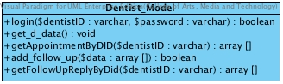

Property

Method

|  |  |  |  |  |
| --- | --- | --- | --- | --- |
| ID | Name | Description | Parameters | Return |
| 1 | login | Method uses to login for dentist | $dentistID:varchar,  $password:varchar | boolean |
| 2 | get_d_data | Method uses to get the dentists’ data from database | - | void |
| 3 | getAppointmentByDID | Method uses to get appointments data of dentist from database by using dentistID | $dentistID:varchar | array [] |
| 4 | add_follow_up | Method uses to add the message for following up the patient | $data : array[] | boolean |
| 5 | getFollowUpReplyByDid | Method uses to get all follow up data as a list by dentistID | $dentistID : varchar | array[] |

CD-02, Class name: Dentist_Manage

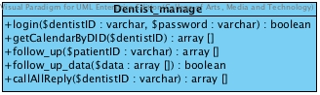

Property

|  |  |  |  |
| --- | --- | --- | --- |
| ID | Name | Description | Remark |
| - | - | - | - |

Method

|  |  |  |  |  |
| --- | --- | --- | --- | --- |
| ID | Name | Description | Parameters | Return |
| 1 | login | Method uses to login for dentist | $dentistID:varchar,$password:varchar | boolean |
| 2 | getCalendarByDID | Method uses to get appointments data  of dentist from database by using dentistID | $dentistID:varchar | array[] |
| 3 | follow_up | Method uses to select patient to follow up by patientID | $patientID : varchar | array[] |
| 4 | follow_up_data | Method uses to get data from follow up | $data : array[] | boolean |
| 5 | callAllReply | Method uses to get all reply follow up message from Dentist_Controller | dentistID : varchar | array[] |

CD-03, Class name: Dentist_Controller

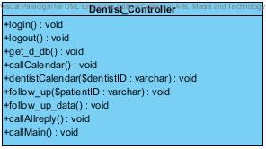

Property

|  |  |  |  |
| --- | --- | --- | --- |
| ID | Name | Description | Remark |
| - | - | - | - |

Method

|  |  |  |  |  |
| --- | --- | --- | --- | --- |
| ID | Name | Description | Parameters | Return |
| 1 | login() | Method uses to login for dentist. | - | void |
| 2 | logout() | Method uses to logout for dentist. | - | void |
| 3 | get_d_db() | Method uses to get dentist data from database | - | void |
| 4 | dentistCalendar | Method uses to get dentist calendar by dentistID | $dentistID:varchar | void |
| 5 | callCalendar | Method uses to call appointment calendar page | - | void |
| 6 | follow_up | Method uses to select patient to follow up by patientID | $patientID : varchar | void |
| 7 | follow_up_data | Method uses to get data from follow up | - | void |
| 8 | callAllreply | Method uses to get all reply follow up message from patient | - | void |
| 9 | callMain | Method uses to call main page | - | void |

CD-04, Class name: Patient_Model

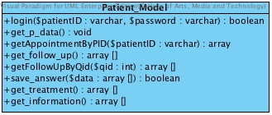

Property

|  |  |  |  |
| --- | --- | --- | --- |
| ID | Name | Description | Remark |
| - | - | - | - |

Method

|  |  |  |  |  |
| --- | --- | --- | --- | --- |
| ID | Name | Description | Parameters | Return |
| 1 | login | Method uses to login for patient. | $patientID:varchar,$password:varchar | boolean |
| 2 | get_p_data() | Method use to get the patients’ data from database | - | void |
| 3 | getAppointmentByID | Method uses to get the appointments’ data from database | $patientID:varchar | array [] |
| 4 | get_follow_up | Method uses to get follow up message as a list from database | - | array[] |
| 5 | getFollowUpByQid | Method use to get the follow up question by question ID | $qid : varchar | array[] |
| 6 | save_answer | Method uses to save the reply answer | $data : array[] | boolean |
| 7 | get_tratement | Method uses to get the dental treatment data as a list from the database | - | array[] |
| 8 | get_information | Method uses to get the dental clinic information and promotion data the database | - | array[] |

CD-05, Class name: Patient_Manage

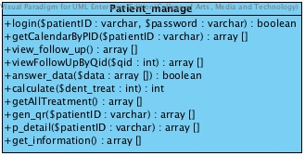

Property

|  |  |  |  |
| --- | --- | --- | --- |
| ID | Name | Description | Remark |
| - | - | - | - |

Method

|  |  |  |  |  |
| --- | --- | --- | --- | --- |
| ID | Name | Description | Parameters | Return |
| 1 | login | Method uses to login for patient. | $patientID:varchar,$password:varchar | boolean |
| 2 | getCalendarByPID | Method uses to get patients’ calendar by using patientID | $patientID:varchar | array [] |
| 3 | view_follow_up | Method uses to display the follow up data from the database | - | void |
| 4 | viewFollowUpByQid | Method use to display the question that patient selected by questionID | $qid : int | array[] |
| 5 | answer_data | Method uses to get the input data from Patient_Controller | $data : array[] | array[] |
| 6 | calculate | Method uses to calculate the dental treatment cost | $dent_treat : int | int |
| 7 | gen_qr | Method uses to generate the patient’s information to be the QR code | - | array[] |
| 8 | p_datail | Method uses to get the personal information of patient including the QR code | - | void |
| 9 | get_information | Method uses to get the dental clinic information and promotion data the database | - | array[] |

CD-06, Class name: Patient_Controller

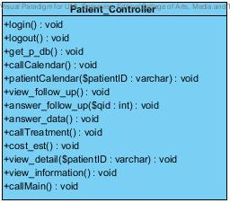

Property

|  |  |  |  |
| --- | --- | --- | --- |
| ID | Name | Description | Remark |
| - | - | - | - |

Method

|  |  |  |  |  |
| --- | --- | --- | --- | --- |
| ID | Name | Description | Parameters | Return |
| 1 | login | Method uses to login for patient. | - | void |
| 2 | logout | Method uses to logout for patient. | - | void |
| 3 | get_p_db | Method uses to get patients’ data from database | - | void |
| 4 | callCalendar | Method uses to call calendar page | - | void |
| 5 | patientCalendar | Method uses to call their own calendar | $patientID:varchar | array [] |
| 6 | view_follow_up | Method uses to display the follow up data from the database | - | void |
| 7 | answer_follow_up($qid) | Method use to select the question to answer by questioned | $qid : int | void |
| 8 | answer_data | Method uses to get the input data from patient | - | void |
| 9 | callTratement | Method uses to get the dental treatment data from the database | - | void |
| 10 | cost_est | Method uses to estimate the cost of dental treatment | - | void |
| 11 | view_datail | Method uses to get the personal information of patient including the QR code | - | void |
| 12 | view_information | Method uses to display the dental clinic information and promotion | - | void |
| 13 | callMain | Method uses to call main page | - | void |

CD-07, Class name: Officer_Model

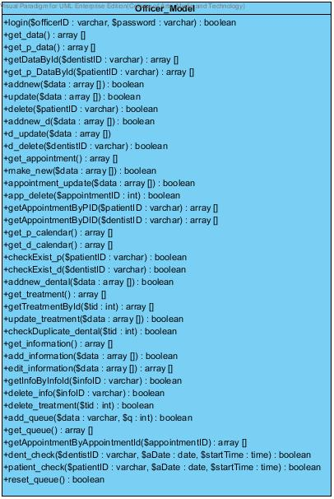

Property

|  |  |  |  |
| --- | --- | --- | --- |
| ID | Name | Description | Remark |
| - | - | - | - |

Method

|  |  |  |  |  |
| --- | --- | --- | --- | --- |
| ID | Name | Description | Parameters | Return |
| 1 | login | Method uses to login for patient. | $dentistID:varchar | void |
| 2 | get_data | Method uses to get all dentists’ data and officers’ data from database | - | array [] |
| 3 | get_p_data | Method uses to get all patients’ data from database | - | array [] |
| 4 | getDataById | Method uses to get data of dentist by using dentistID | $dentistID:varchar | array [] |
| 4 | get_p_DataById | Method uses to get data of patient by using patientID | $pateintID:varchar | array [] |
| 5 | addnew | Method uses to add new patient to the database | $data:array[] | boolean |
| 6 | update | Method uses to update patients’ data to database | $data:array[] | boolean |
| 8 | delete | Method uses to delete patient from database by using of patientID | $patientID:varchar | boolean |
| 9 | addnew_d | Method uses to add new dentist to the database | $data:array[] | boolean |
| 10 | d_update | Method uses to update dentists’ data to database | $data:array[] | boolean |
| 11 | get_appointment | Method uses to get data of appointments from database | - | array [] |
| 12 | make_new | Method uses to add new appointment to database | $data:varchar | boolean |
| 13 | appointment_update | Method uses to update appointments’ data to database | $data:varchar | boolean |
| 14 | app_delete | Method uses to delete appointments’ data from database | $appointmentID:int | boolean |
| 15 | getAppointmentByPID | Method uses to get appointments’ data from database by using patientID | $patientID:varchar | array [] |
| 16 | getAppointmentByDID | Method uses to get appointments’ data from database by using dentistID | $dentistID:varchar | array [] |
| 17 | get_p_calendar | Method uses to get all appointments’ data from database | - | array [] |
| 18 | get_d_calendar | Method uses to get all appointments’ data from database | - | array [] |
| 19 | checkExist_p | Method uses to check that the patientID is already exist or not | $patientID:varchar | boolean |
| 20 | checkExist_d | Method uses to check that the dentistID is already exist or not | $dentistID:varchar | boolean |
| 21 | addnew_dental | Method uses to add new dental treatment to the database | - | boolean |
| 22 | get_treatment | Method uses to get all the follow up data from database | - | array[] |
| 23 | getTreatmentById | Method uses to get dental treatment data by treatmentID | $tid : int | array[] |
| 24 | update_treatment | Method uses to update the dental treatment data | $data : array | boolean |
| 25 | checkDuplicate_dental | Method uses to check the duplication of the dental clinic data by checking the id of each dental treatment | $tid : int | boolean |
| 26 | get_information | Method uses to get all dental clinic information into the database | - | array[] |
| 27 | add_information | Method uses to add new dental clinic information or promotion into the database | $data : array[] | boolean |
| 28 | edit_information | Method uses to edit the dental clinic information or promotion | $data : array[] | array[] |
| 29 | get_InfoByInfoId | Method uses to get the dental clinic information or promotion data by informationID | $InfoID : int | boolean |
| 30 | delete_info | Method uses to delete dental clinic information or promotion | $infoID : int | boolean |
| 31 | delete_treatment | Method uses to delete dental treatment by tid | $tid : int | boolean |
| 32 | add_queue | Method uses to add the patient ‘appointment into the queue by using patientID | $pid : varchar  $q : int | boolean |
| 33 | get_queue | Method uses to get the patient ‘appointment queue from the database | - | array[] |
| 34 | getAppointmentByAppointmentId | Method uses to get appointment from database by appointmentID | $appointmentID : int | array[] |
| 35 | dent_check | Method uses to check available time of dentist | $dentistID : varchar  $aDate : date  $startTime : time | boolean |
| 36 | patient_check | Method uses to check available time of patient | $patientID : varchar  $aDate : date  $startTime : time | boolean |
| 37 | reset_queue | Method uses to reset queue | - | boolean |

CD-08, Class name: Officer_Manage

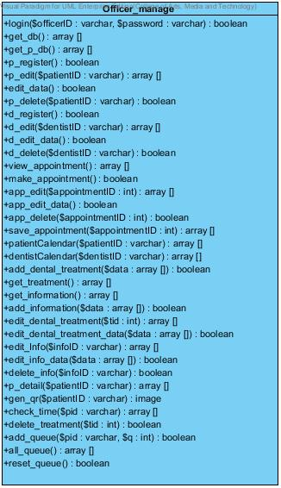

Property

|  |  |  |  |
| --- | --- | --- | --- |
| ID | Name | Description | Remark |
| - | - | - | - |

Method

|  |  |  |  |  |
| --- | --- | --- | --- | --- |
| ID | Name | Description | Parameters | Return |
| 1 | login | Method uses to login for officer. | $patientID:varchar | boolean |
| 2 | get_db | Method uses to get all dentists’ data and officers’ data from database | - | array[] |
| 3 | get_p_db | Method uses to get all patients’ data from database | - | array[] |
| 4 | p_register | Method uses to register new patient to the database | - | boolean |
| 5 | p_edit | Method uses to get patient’s data for edit | $patientID:varchar | array [] |
| 6 | edit_data | Method uses to collect new data of patient for edit | - | boolean |
| 7 | p_delete | Method uses to delete patient from database by using of patientID | $patientID:varchar | boolean |
| 8 | d_register | Method uses to add new dentist to the database | - | boolean |
| 9 | d_edit | Method uses to get dentist’s data for edit | $dentistID:varchar | array [] |
| 10 | d_edit_data | Method uses to collect new data of dentist for edit | - | boolean |
| 11 | d_delete | Method uses to delete dentist from database by using of dentistID | $dentistID:varchar | boolean |
| 12 | view_appointment | Method uses to get data of appointments from database | - | array[] |
| 13 | make_appointment | Method uses to add new appointment to database | - | boolean |
| 14 | app_edit | Method uses to get appointment’s data for edit | $appointmentID:int | array[] |
| 15 | app_edit_data | Method uses to collect new data of appointment for edit | - | boolean |
| 16 | app_delete | Method uses to delete appointments’ data from database | $appointmentID:int | boolean |
| 17 | save_appointment | Method uses to call appointments’ data from database to save to Google calendar | $appointmentID:int | array [] |
| 18 | patientCalendar | Method uses to get all appointments’ data from database by using patientID | $patientID:varchar | array [] |
| 19 | dentistCalendar | Method uses to get all appointments’ data from database by using dentistID | $dentistID:varchar | array [] |
| 20 | add_dental_treatment | Method uses to add new dental treatment to the database | $data : varchar | boolean |
| 21 | get_treatment | Method uses to get all dental treatment data from the database | - | array[] |
| 22 | get_information | Method uses to get all information and promotion as a list | - | array[] |
| 23 | add_information | Method uses to add new dental clinic information or promotion into the database | - | boolean |
| 24 | edit_dental_treatment | Method uses to select dental treatment for editing by tid | $tid : int | array[] |
| 25 | edit_dental_treatment_data | Method uses to edit some dental 26treatment detail | $data : array[] | boolean |
| 26 | edit_info | Method uses to select the dental clinic information or promotion by infoID | $infoID : int | array[] |
| 27 | edit_info_data | Method uses to edit the dental clinic information or promotion | $data : array[] | boolean |
| 28 | delete_info | Method uses to delete the dental clinic information or promotion by infoID | $infoID : int | boolean |
| 29 | p_detail | Method uses to display the patient ‘s detail by patientID | $patientID : varchar | array[] |
| 30 | gen_qr | Method uses to generate patient’s information to be the QR code | $patientID : varchar | image |
| 31 | check_time | Method uses to check patient appointment time by patientID | $pid : varchar | array[] |
| 32 | delete _treatment | Method uses to delete dental treatment by tid | $tid : int | boolean |
| 33 | add_queue | Method uses to add the patient ‘appointment into the queue by using patientID | $pid : varchar  $q : int | boolean |
| 34 | all_queue | Method uses to get the patient ‘appointment queue from the database | - | array[] |
| 35 | reset_queue | Method uses to reset queue from database | - | boolean |

CD-09, Class name: Officer_Controller

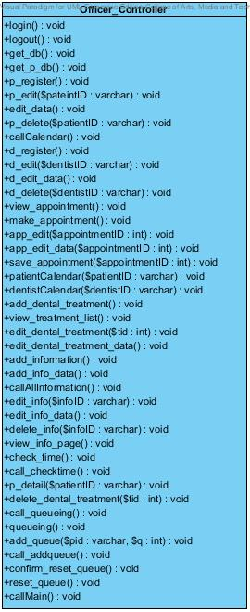

Property

|  |  |  |  |
| --- | --- | --- | --- |
| ID | Name | Description | Remark |
| - | - | - | - |

Method

|  |  |  |  |  |
| --- | --- | --- | --- | --- |
| ID | Name | Description | Parameters | Return |
| 1 | login | Method uses to login for patient. | - | void |
| 2 | logout | Method uses to logout for patient. | - | void |
| 3 | get_db | Method uses to get all dentists’ data and officers’ data from database | - | void |
| 4 | get_p_db | Method uses to get all patients’ data from database. | - | void |
| 5 | p_register | Method uses to register new patient to the system | - | void |
| 6 | p_edit | Method uses to call patient edit page with appointment data | $patientID:varchar | void |
| 7 | edit_data | Method uses to save the edit data of patient to the database | - | void |
| 8 | p_delete | Method uses to delete any patient from the system and database | $patientID:varchar | void |
| 9 | callCalendar | Method uses to call calendar from google calendar | - | void |
| 10 | d_register | Method uses to register new dentist to the system | - | void |
| 11 | d_edit | Method uses to call dentist edit page with dentist data | $dentistID:varchar | void |
| 12 | d_edit_data | Method uses to save the edit data of dentist to the database | - | void |
| 13 | d_delete | Method uses to delete any dentist from the system and database | $dentistID:varchar | void |
| 14 | view_appointment | Method uses to get all appointment data to view | - | void |
| 15 | make_appointment | Method uses to make new appointment | - | void |
| 16 | app_edit | Method uses to call appointment edit page with appointment data | $appointmentID:varchar | void |
| 17 | app_edit_data | Method uses to save the edit data of appointment to the database | - | void |
| 18 | app_delete | Method uses to delete any appointment from the system and database | $appointmentID:varchar | void |
| 19 | save_appointment | Method uses to save appointment to google calendar | $appointmentID:varchar | void |
| 20 | patientCalendar | Method uses to get patients’ calendar by using patientID | $patientID:varchar | void |
| 21 | dentistCalendar | Method uses to get dentists’ calendar by using dentistID | $dentistID:varchar | void |
| 22 | add_dental_treatment | Method uses to add new dental treatment to the database | - | void |
| 23 | view_treatment_list | Method uses to display all dental treatment data as a list in the all treatment page in the website | - | void |
| 24 | edit_dental_treatement | Method uses to select the dental treatment for editing by tid | $tid : int | void |
| 25 | edit_dental_treatment_data | Method uses to edit dental treatment data | - | void |
| 26 | add_information | Method uses to add new dental clinic information or promotion to the database | - | void |
| 27 | add_info_data | Method uses to add new dental clinic information or promotion to the database | - | void |
| 28 | callAllInformation | Method uses to display all information and promotion as a list | - | void |
| 29 | edit_info | Method uses to selects the information to editing by InfoID | $infoID : int | void |
| 30 | edit_info_data | Method uses to edit some detail of dental clinic information or promotion | - | void |
| 31 | delete_info | Method uses to delete the dental clinic information or promotion | $infoID : int | void |
| 32 | view_info_page | Method uses to display dental clinic information and promotion | - | void |
| 33 | check_time | Method uses to check patient appointment time | - | void |
| 34 | call_checkTime | Method uses to get the list of patient appointment after checking the time | - | void |
| 35 | p_detail | Method uses to display the patient ‘s detail by patientID | $patientID : varchar | array[] |
| 36 | delete_dental_treatment | Method uses to delete dental treatment by tid | $tid : int | void |
| 37 | call_queueing | Method uses to get all the patient’s appointment queue | - | void |
| 38 | queueing | Method uses to check the patient’s appointment queue | - | void |
| 39 | add_queue | Method uses to add patient’s appointment in to the queue | $pid:varcahr,  $q : int | void |
| 40 | call_addqueue | Method uses to get the patient’s appointment queue after add the queue | - | void |
| 41 | confirm_reset_queue | Method uses to confirm to reset queue | - | void |
| 42 | reset_queue | Method uses to reset queue | - | void |
| 43 | callMain | Method uses to call main page | - | void |

### 

### **4.2.2 Class Diagram Description (DCSS mobile application)**

CD-10, Class name: PatientMobile_Model

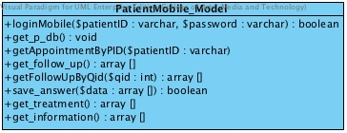

Property

|  |  |  |  |
| --- | --- | --- | --- |
| ID | Name | Description | Remark |
| - | - | - | - |

Method

|  |  |  |  |  |
| --- | --- | --- | --- | --- |
| ID | Name | Description | Parameters | Return |
| 1 | loginMobile | Method uses to login for patient in mobile application. | - | void |
| 2 | get_p_db | Method uses to get patients’ data from database | - | void |
| 3 | getAppointmentByPID | Method uses to call their own appointment in mobile application by using patientID | $patientID:varchar | array [] |
| 4 | view_follow_up | Method uses to display the follow up data from the database | - | void |
|  | answer_follow_up($qid) | Method use to select the question to answer by questioned | $qid : int | void |
| 5 | answer_data | Method uses to get the input data from patient | - | void |
| 6 | call_treatment | Method uses to get the dental treatment data from the database | - | void |
| 7 | cost_est | Method uses to gestimate the dental treatment cost | - | void |
| 8 | p_detail | Method uses to display the patient ‘s detail by patientID | $patientID : varchar | array[] |
| 9 | view_information | Method uses to display the dental treatment data from the database | - | void |

CD-11, Class name: PatientMobile_manage

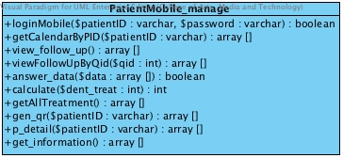

Property

|  |  |  |  |
| --- | --- | --- | --- |
| ID | Name | Description | Remark |
| - | - | - | - |

Method

|  |  |  |  |  |
| --- | --- | --- | --- | --- |
| ID | Name | Description | Parameters | Return |
| 1 | loginMobile | Method uses to login for patient in mobile application. | $patientID:varchar,$password:varchar | boolean |
| 2 | getCalendarByPID | Method uses to get patients’ calendar by using patientID in mobile application | $patientID:varchar | array [] |
| 3 | view_follow_up | Method uses to display the follow up data from the database | - | void |
| 4 | viewFollowUpByQid | Method use to display the question that patient selected by questionID | $qid : int | array[] |
| 5 | answer_data | Method uses to get the input data from Patient_Controller | $data : array[] | array[] |
| 6 | calculate | Method uses to calculate the dental treatment cost | $dent_treat : int | int |
| 7 | getAllTreatment | Method uses to get all dental treatment form the database | - | array[] |
| 8 | gen_qr | Method uses to generate the patient’s information to be the QR code | $patientID : varchar | array[] |
| 9 | p_datail | Method uses to get the personal information of patient including the QR code | $patientID : varchar | void |
| 10 | get_information | Method uses to get the dental treatment data from the database | - | void |

CD-12, Class name: PatientMobile_Controller

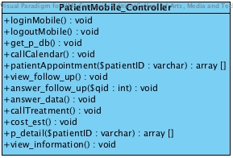

Property

|  |  |  |  |
| --- | --- | --- | --- |
| ID | Name | Description | Remark |
| - | - | - | - |

Method

|  |  |  |  |  |
| --- | --- | --- | --- | --- |
| ID | Name | Description | Parameters | Return |
| 1 | loginMobile | Method uses to login for patient in mobile application. | - | void |
| 2 | logoutMobile | Method uses to logout for patient from mobile application. | - | void |
| 3 | get_p_db | Method uses to get patients’ data from database | - | void |
| 4 | callCalendar | Method uses to call calendar page in mobile application | - | void |
| 5 | patientAppointment | Method uses to call their own appointment in mobile application | $patientID:varchar | array[] |
| 6 | view_follow_up | Method uses to display the follow up data from the database | - | void |
| 7 | answer_follow_up($qid) | Method use to select the question to answer by questioned | $qid : int | void |
| 8 | answer_data | Method uses to get the input data from patient | - | void |
| 9 | call_treatment | Method uses to get the dental treatment data from the database | - | void |
| 10 | cost_est | Method uses to gestimate the dental treatment cost | - | void |
| 11 | p_detail | Method uses to display the patient ‘s detail by patientID | $patientID : varchar | array[] |
| 12 | view_information | Method uses to display the dental treatment data from the database | - | void |

# Chapter Five: Sequence Diagram

## 5. Sequence Diagram

## 5.1 DCSS website Sequence Diagram

## SD-01: Login

* **URS-15**

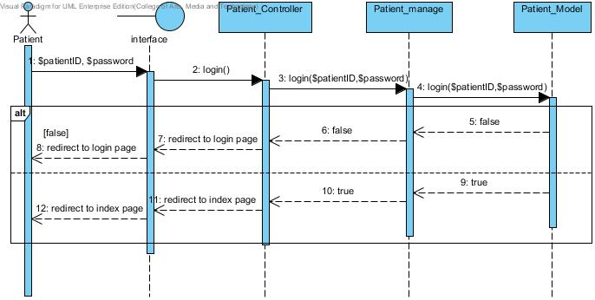

Figure 5: Patient Login

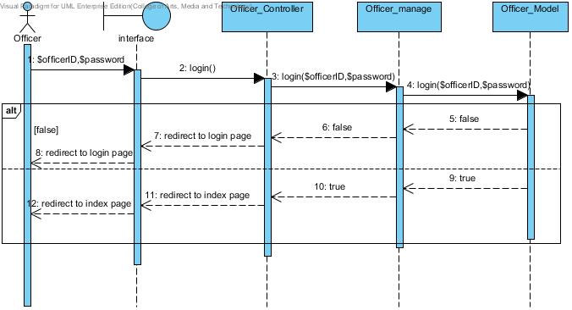

Figure 6: Officer Login

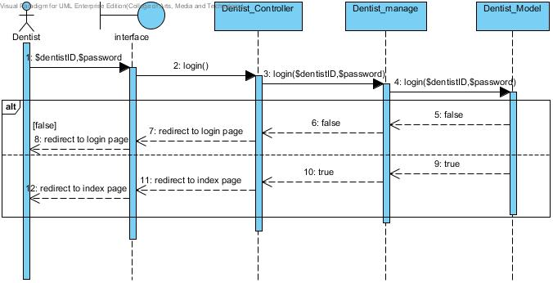

Figure 7: Dentist login

**SD-02: Logout**

* **URS-17**

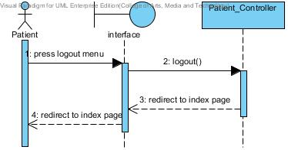

Figure 8: Patient logout

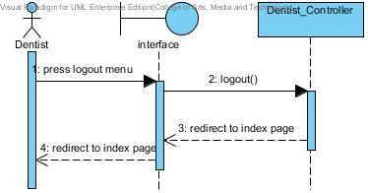

Figure 9: Officer logout

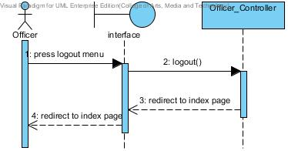

Figure 10: Dentist Logout

**SD-03: View dental clinic calendar**

* **URS-09**

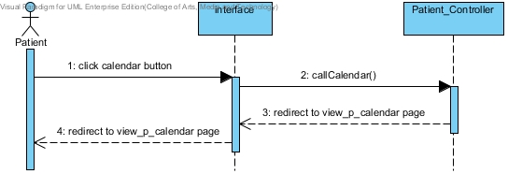

Figure 11: Patient view dental clinic calendar

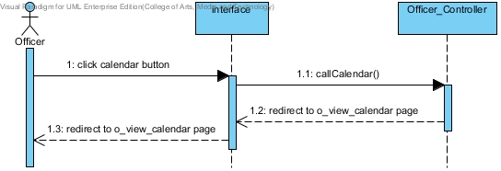

Figure 12: Officer view dental clinic calendar

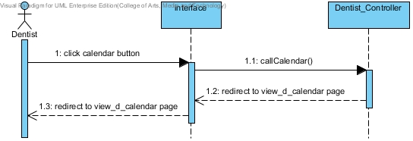

Figure 13: Dentist view dental clinic calendar

**SD-04: View his/her own appointment**

* **URS-03**

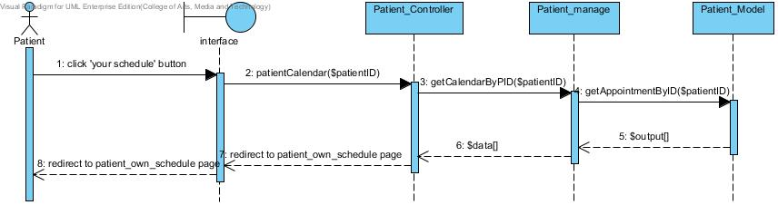

Figure 14: Patient can view his/her own appointment

* **URS-04**

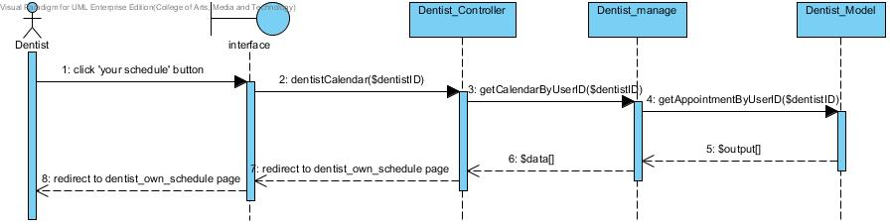

Figure 15: Dentist can view his/her own appointment

**SD-05: View all appointment in dental clinic**

* **URS-06**

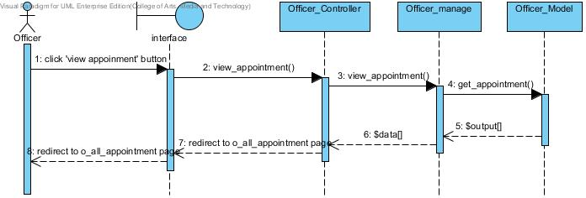

Figure 16:Officer can view all appointment in dental clinic

**SD-06:Create patient account**

* **URS-18**

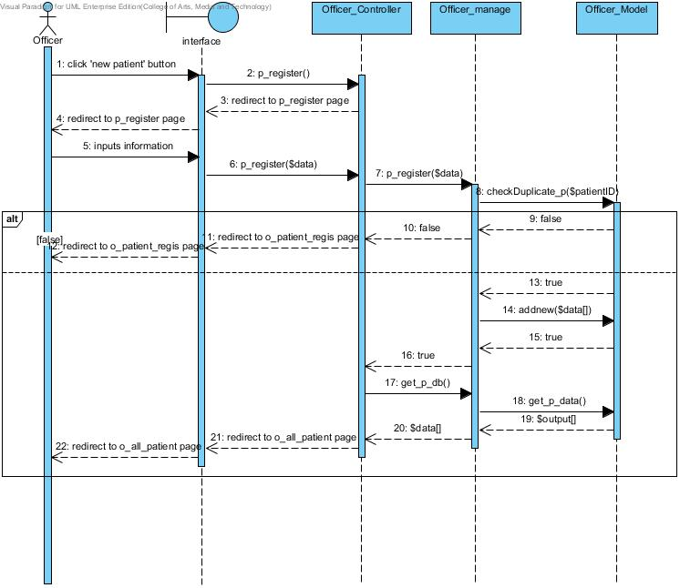

Figure 17: Officer can create new patient account and the list of all patients show after register.

**SD-07: Create dentist account**

* **URS-21**

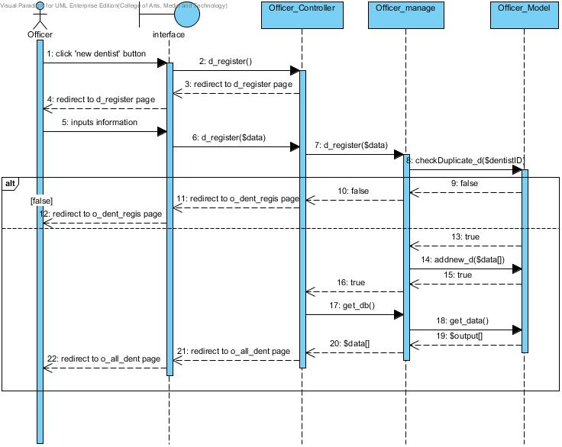

Figure 18: Officer can create new dentist account and the list of all clinic user shows after register

**SD-08: View all patients as a list**

* **URS-24**

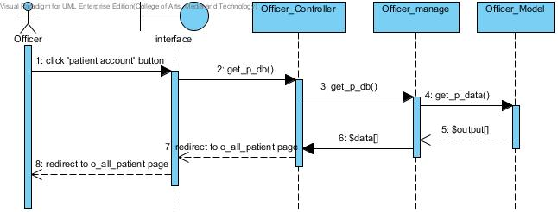

Figure 19: Officer can view all patients as a list

**SD-09: View all dentist as a list**

* **URS-25**

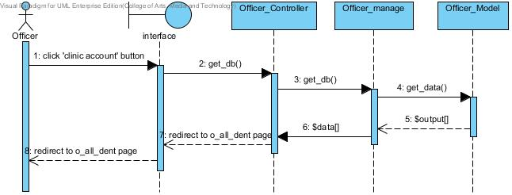

Figure 20: Officer can view all dentists in the list

**SD-10: Make an appointment**

* **URS-10**

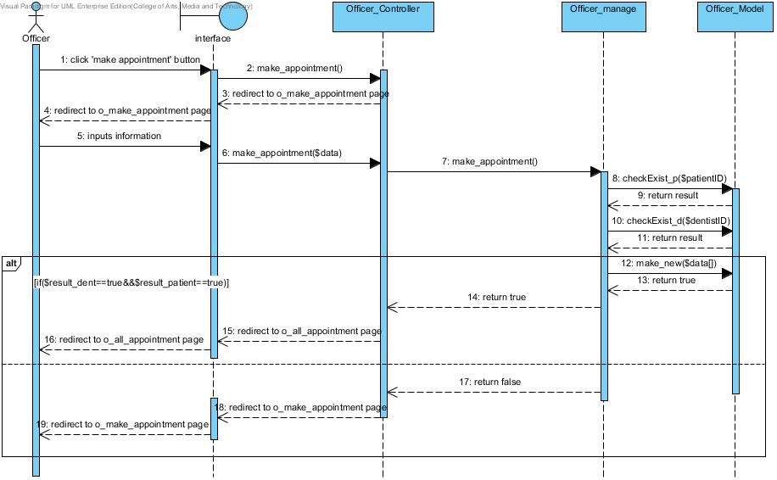

Figure 21: Officer can add new appointment into the database and it will update in the dental clinic appointment schedule

**SD-11: Edit an appointment**

* **URS-11**

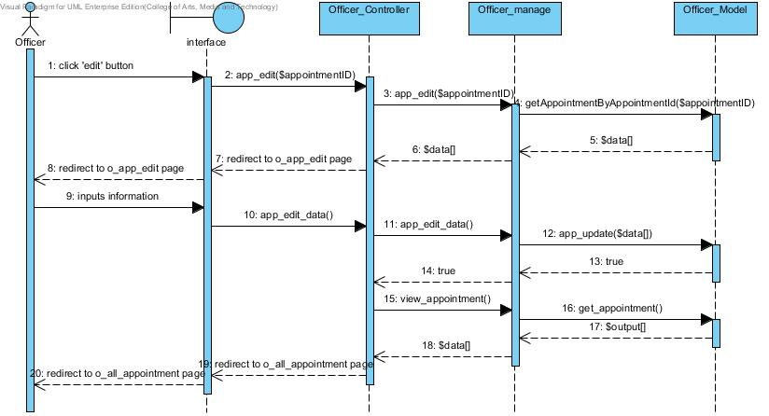

Figure 22: Officer can edit an appointment into the database and it will update in the dental clinic appointment schedule

**SD-12: Delete an appointment**

* **URS-12**

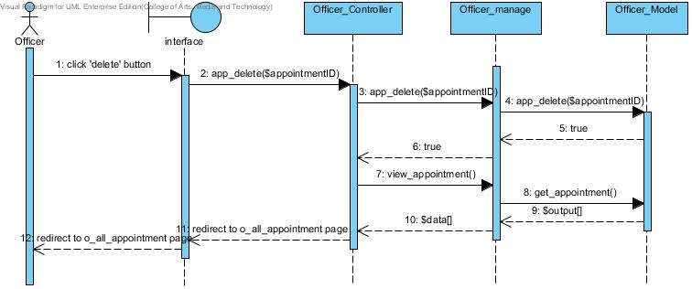

Figure 23: Officer can delete an appointment into the database and it will update in the dental clinic appointment schedule

**SD-13: Edit patients’ account**

* **URS-19**

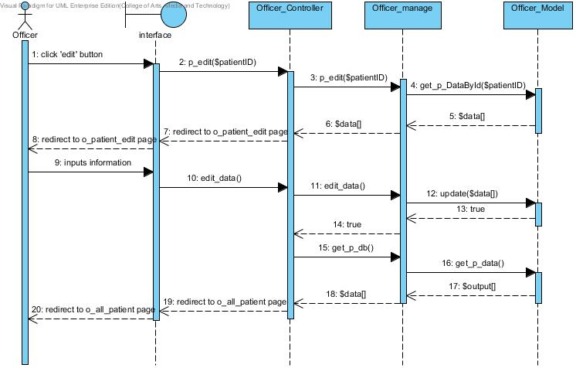

Figure 24: Officer can edit patients’ account and the list of all patients shows after edit

**SD-14: Edit dentists’ account**

* **URS-22**

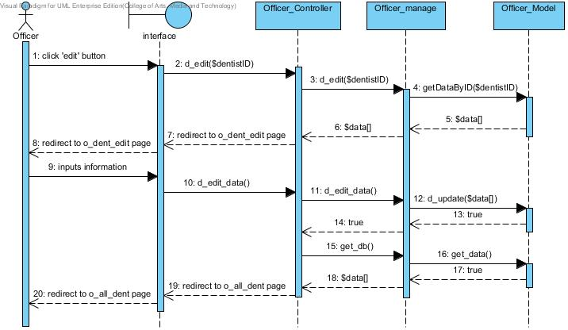

Figure 25: Officer can edit dentists’ account and the list of all clinic users shows after edit

**SD-15: Delete patients’ account**

* **URS-20**

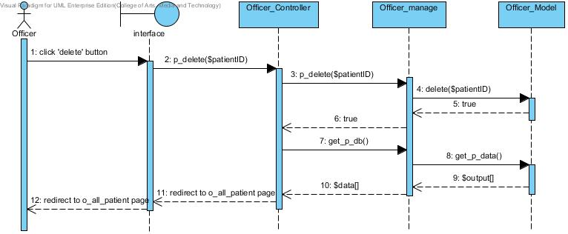

Figure 26: Officer can delete patients’ account and the list of all patients shows after edit

**SD-16: Delete dentists’ account**

* **URS-23**

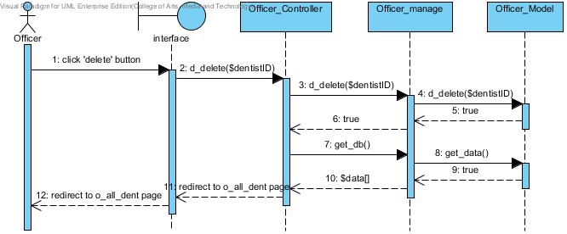

Figure 27: Officer can delete dentists’ account and the list of all dentists shows after edit

**SD-17: Save appointment to Google Calendar**

* **URS-13**

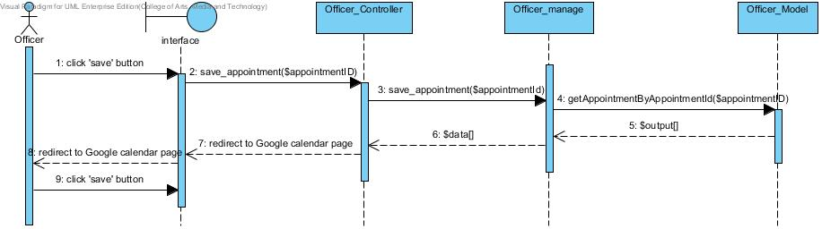

Figure 28: Officer can save an appointment to Google Calendar by using dental clinic services system Google accou

**SD-23: Officer view dentists’ appointment**

* **URS-08**

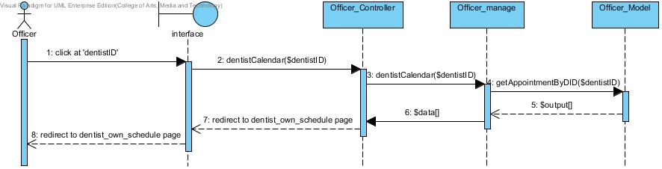

Figure 29: Officer views dentists’ appointment

**SD-24: Officer view patients’ appointment**

* **URS-07**

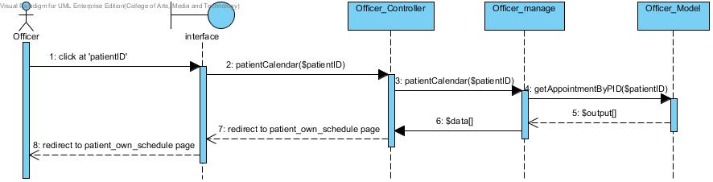

Figure 30: Officer views patients’ appointment

**SD-25: View follows up page**

* 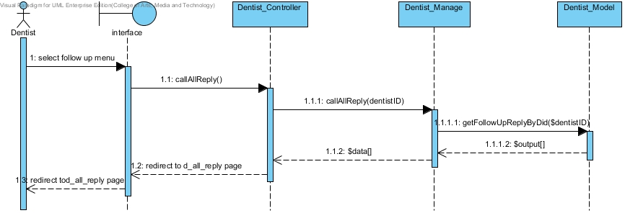**URS-31:** Dentist can view his/her patient follow up message as a list

Figure 31 : dentist view dentist follow up message in the website

* **URS-33:** Patient can view follow up massage that his/her dentist asked in the websiteas a list

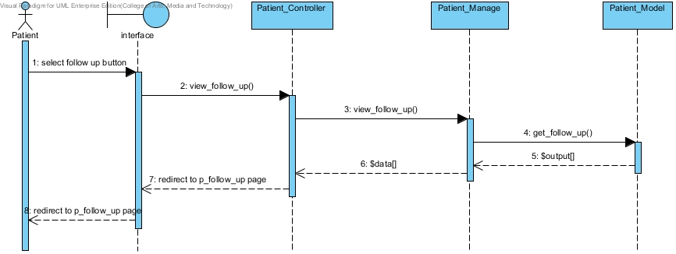

Figure 32 : patient view dentist follow up message in the website

**SD-26: Follows up message**

* **URS-32:** Dentist can post question to follow up his/her patient 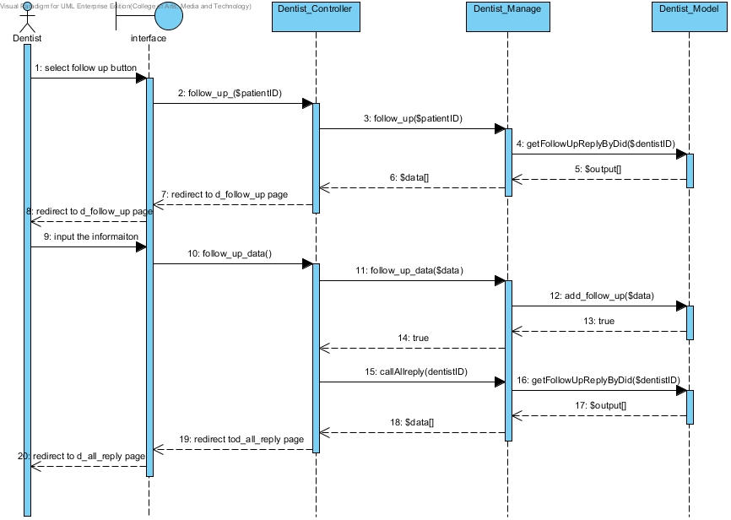

Figure 33 : Dentist ask his/her patient follow up message

* **URS-34:** Patient can answer follow up massage that his/her dentist asked in the websiteas a list

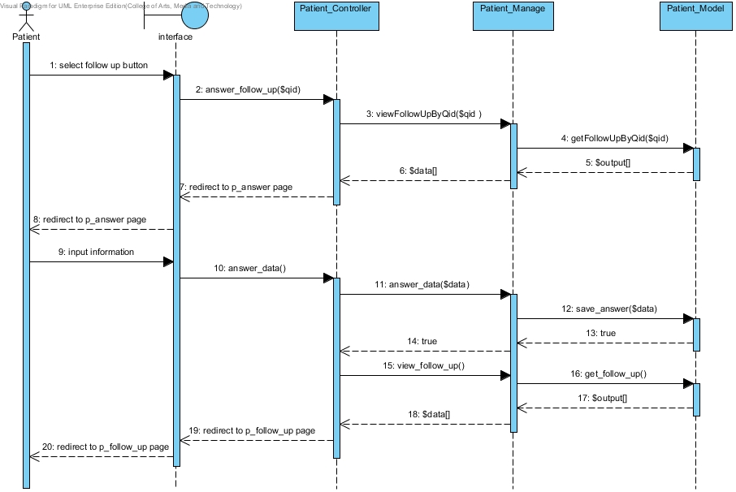

Figure 34 : Patient answer his/her follow up message

**SD-27: View dental clinic information and promotion**

* **URS-37:** Patient can view the dental clinic information and promotion in the website

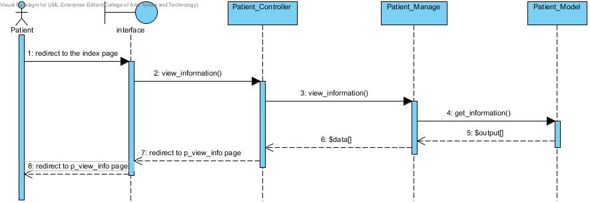

Figure 35 : Patient can view the dental clinic information and promotion

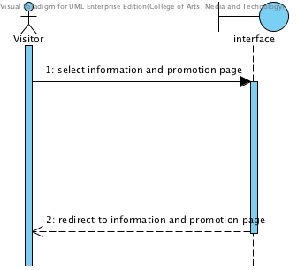

Figure 36 : Visitor can view the dental clinic information and promotion

**SD-28: Add dental clinic information and promotion**

* **URS-39: Officer can add the information and promotion to the database**

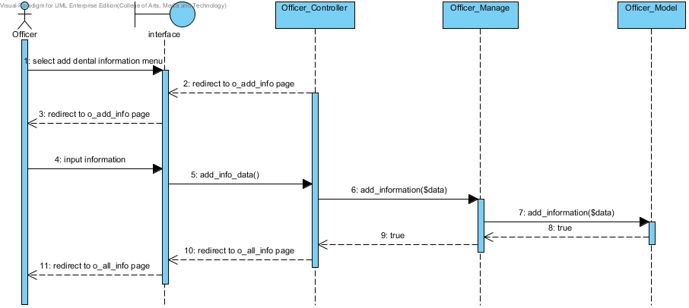

Figure 37 : Officer can add the information or promotion

**SD-29: Edit dental clinic information and promotion**

* **URS-40: Officer can edit the dental clinic information and promotion in the database**

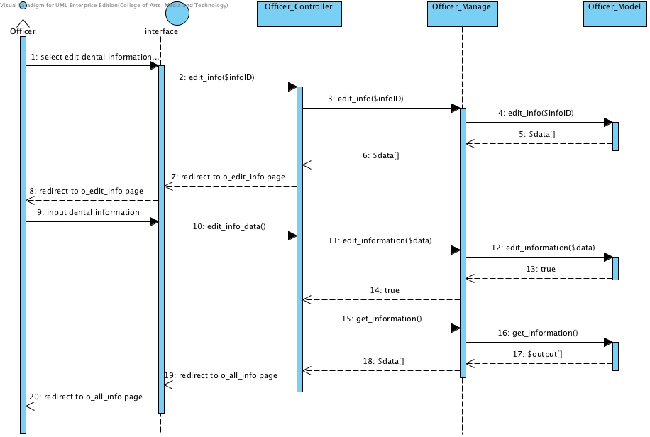

Figure 38 : Officer can edit the dental clinic information or promotion

**SD-30: Delete dental clinic information and promotion**

* **URS-41: Officer can delete the dental clinic information and promotion from the database**

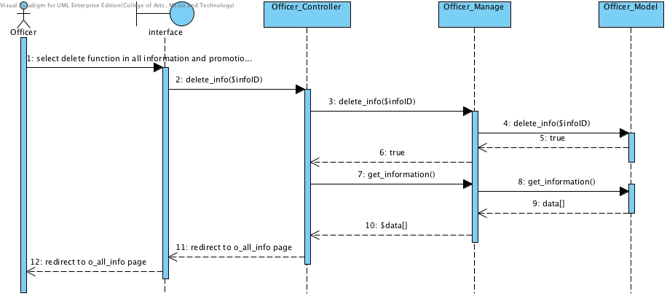

Figure 39: Officer can delete the dental clinic information or promotion

**SD-31: Cost estimation of dental treatments**

* **URS-43: Patient can select the dental treatment to estimate the cost by his/herself in the website**

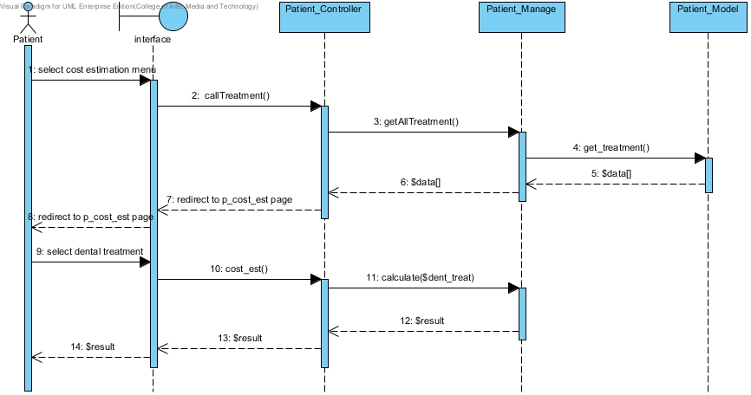

Figure 40: Estimate the dental treatment cost

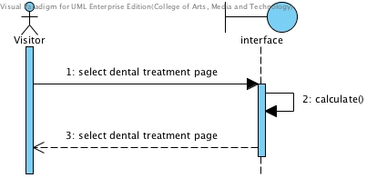

Figure 41: Visitor estimate the dental treatment cost

**SD-32: Add dental treatment**

* **URS-46: Officer can add dental treatment information including the detail and cost into the database**

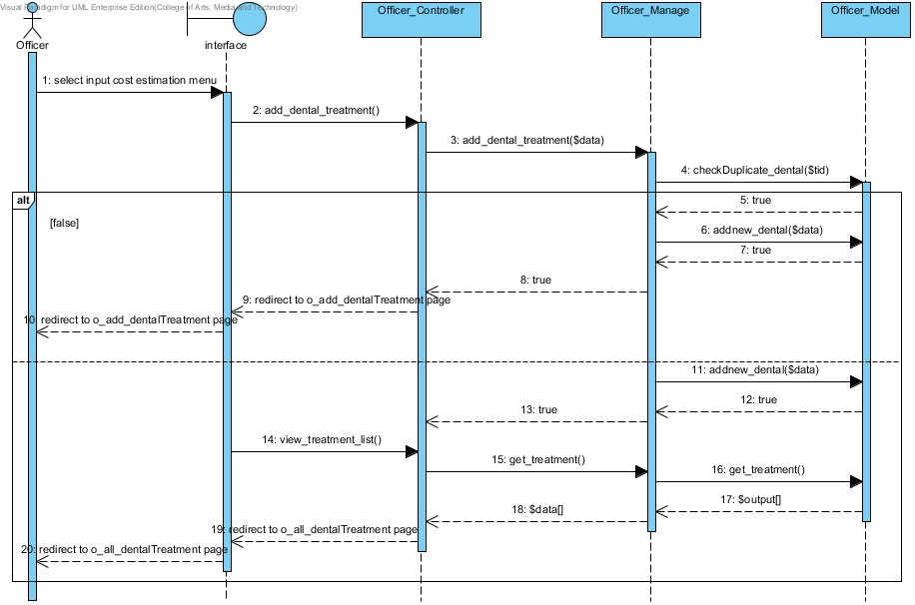

Figure 42: Officer can add dental treatment information

**SD-33: Edit dental treatment**

* **URS-47: Officer can edit dental treatment information including the detail and cost in the database**

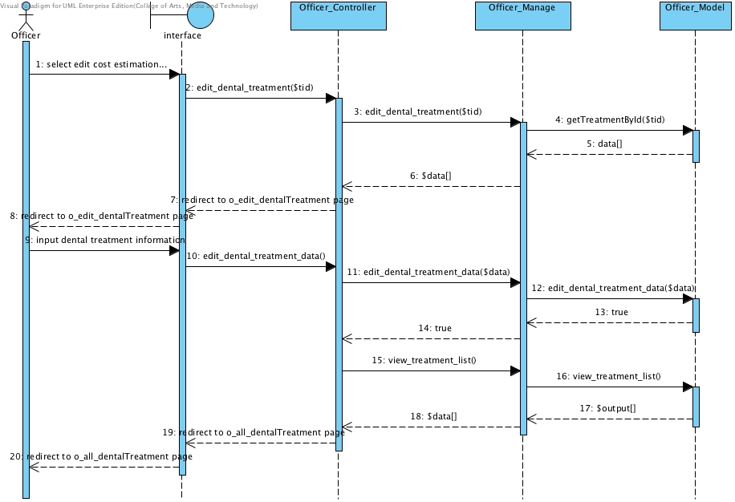

* Figure 43: Officer can edit dental treatment information

**SD-34: Delete dental treatment**

* **URS-48: Officer can delete dental treatment information from the database**
* 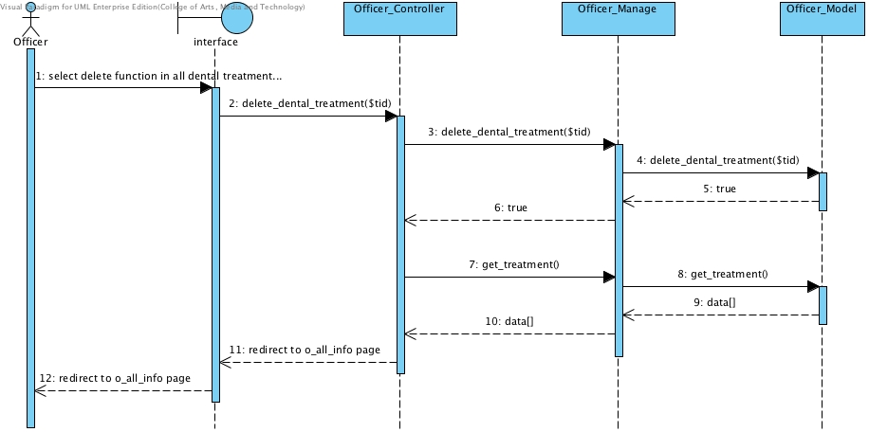
* Figure 44: Officer can edit delete treatment information

**SD-35: Patient can view their QR code from website**

* **URS-27: Patient can view their QR code from website**

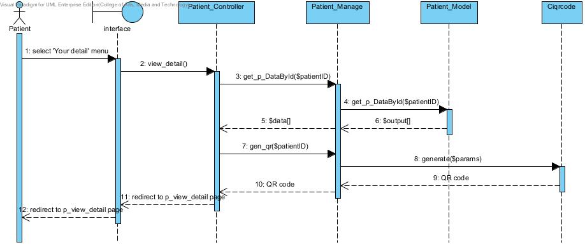

Figure 45: View their QR code from website

**SD-36: Officer can add patient to a queue**

* **URS-28: Officer can add patient to a queue**

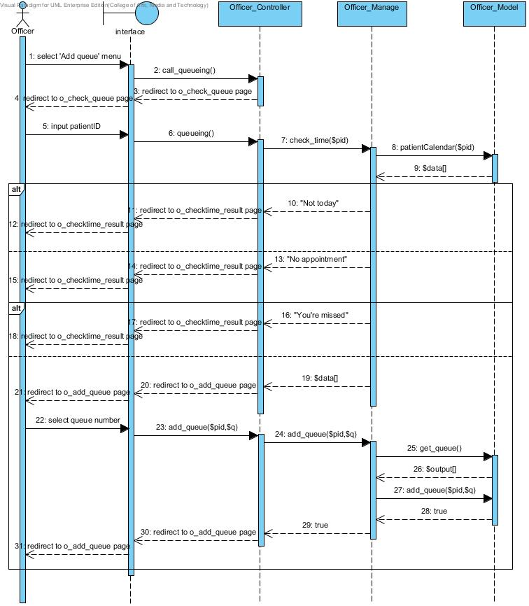

Figure 46: Officer can add patient to a queue

**SD-37: Officer can reset queue**

* **URS-29: Officer can reset queue**

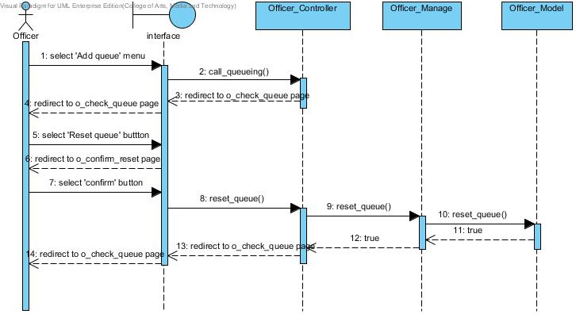

Figure 21: Officer can reset queue

**SD-44: Officer can view identification result of patient**

* **URS-30: Officer can view patients’ identification result**

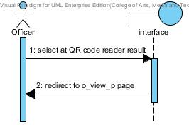

Figure 47: Officer can view patients’ identification result from QuickMark

## 

## 5.2 DCSS mobile application Sequence Diagram

**SD-18: Login to the mobile application**

* **URS-14**

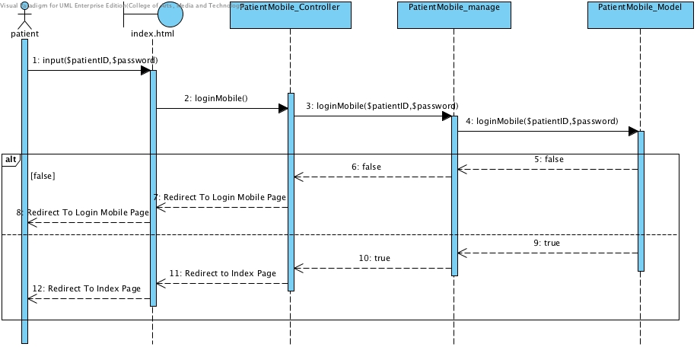Figure 48: Patient can login to the mobile application

**SD-19: View his/her own appointment**

* 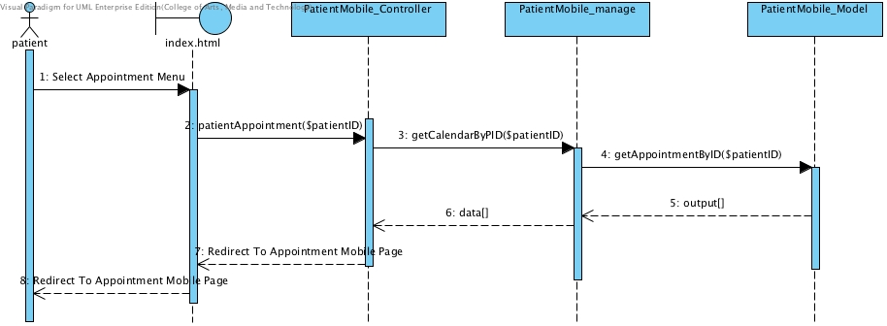**URS-01**

Figure 49: Patient can view his/her appointment after login if user does not login the appointment will not display

**SD-20: View appointment in Google calendar**

* **URS-02**

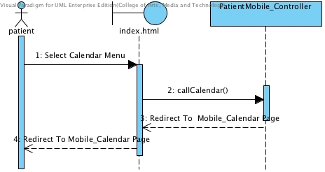

Figure 50: Patient can view all appointment in Google calendar

**SD-21: Logout from mobile application**

* **URS-16**

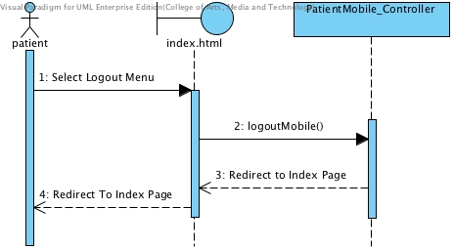

Figure 51: Patient logout from mobile application

**SD-22: Visitor can view all appointment from Google calendar**

* **URS-05**

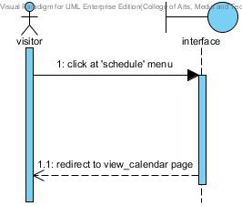

Figure 52: Visitor can view all appointment from Google calendar

**SD-38: Use QR code to identify him/herself**

* **URS-26: Patient can view their QR code from mobile application**

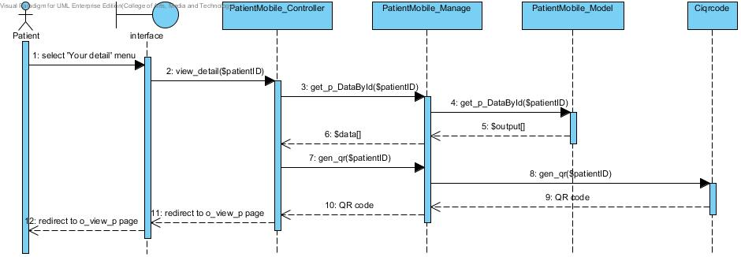

Figure 53 : patient view the QR code the mobile application

**SD-39: View the follow message in mobile application**

* **URS-35: Patient can view follow up massage that his/her dentist asked in mobile application as a list**

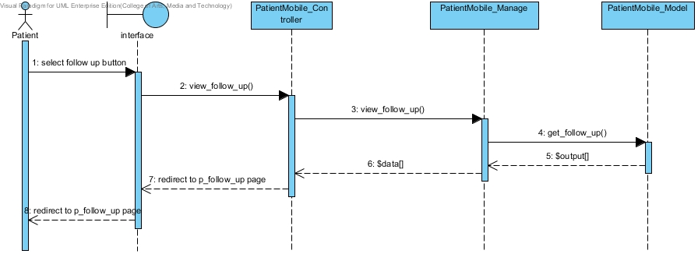

* Figure 54: Patient can view his/her dentist follow up message in the mobile application

**SD-40: Reply the message the follow message in mobile application**

* **URS-36: Patient can answer view follow up massage that his/her dentist asked in mobile application as a list**

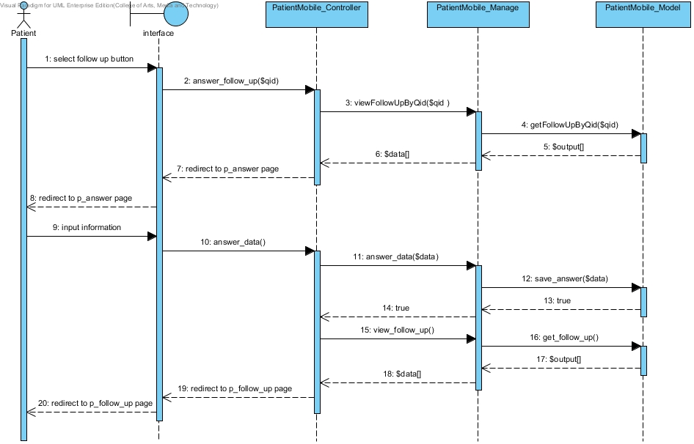

* Figure 55: Patient can answer his/her dentist follows up message in mobile application

**SD-41: View dental clinic information and promotion in the mobile application**

* **URS-38: Patient can view the dental clinic information and promotion in mobile application**
* 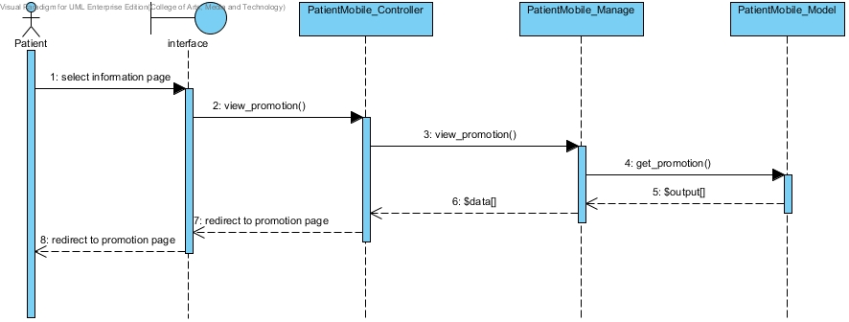
* Figure 56: Patient can view the dental clinic information and promotion in mobile application

**SD-42: Estimate the cost of dental treatment in mobile application**

* **URS-44: Patient can select the dental treatment to estimate the cost by him/herself in the mobile application**

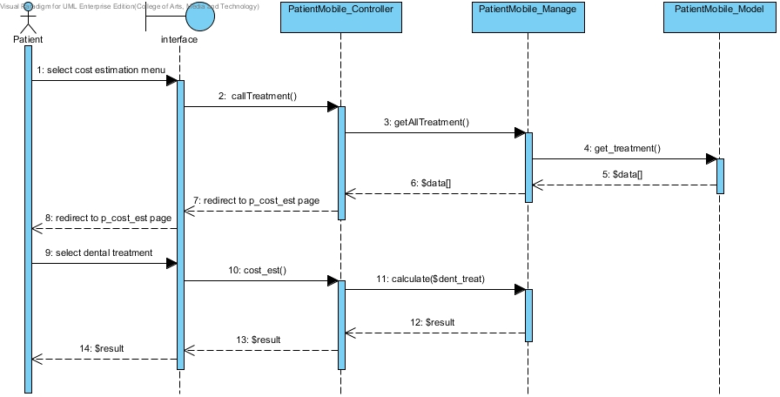

Figure 57: Estimate dental treatment to estimate the cost in the mobile application

**SD-43: Officer can view dental treatment information as a list**

* **URS-49: Officer can view dental treatment information as a list**

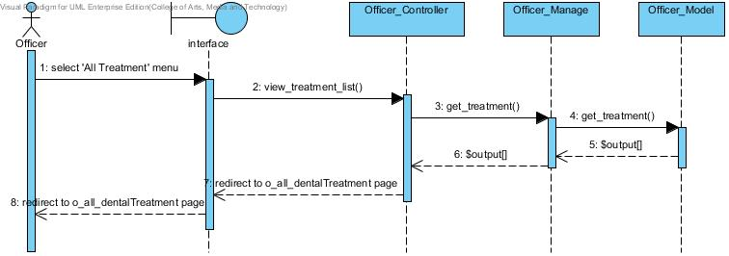

Figure 58: View dental treatment information as a list

# Chapter Six: Database Design

## 6. Database Design

## 6.1 Database design

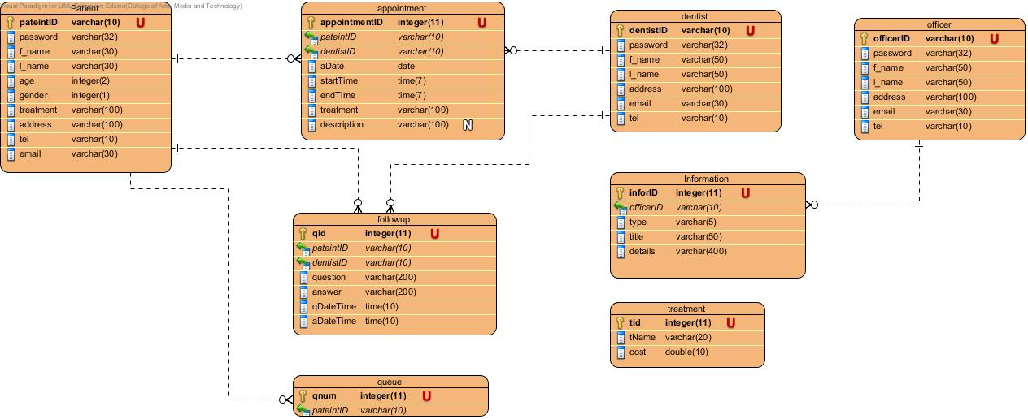

Figure 59: Database Diagram of Dental Clinic Services System

## **6.2 Database Description**

DB-01: patient

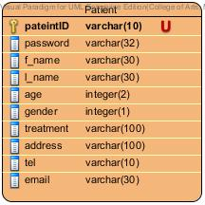

Description

|  |  |  |  |  |  |  |
| --- | --- | --- | --- | --- | --- | --- |
| **Field Name** | **Description** | **Type** | **Length** | **Primary Key** | **Foreign Key** | **Nullable** |
| patientID | patientID | varchar | 10 | PK | - | Not Null |
| password | Password of patient | varchar | 30 | - | - | Not Null |
| f_name | First name of patient in English | varchar | 50 | - | - | Not Null |
| l_name | Last name of patient in English | varchar | 50 | - | - | Not Null |
| age | Ages of patient | int | 2 | - | - | Not Null |
| gender | Gender of patient | int | 1 | - | - | Not Null |
| treatment | Treatment that patient have | varchar | 100 | - | - | Not Null |
| address | Address of patient in English | varchar | 100 | - | - | Not Null |
| tel | Telephone number of patient | varchar | 10 | - | - | Not Null |
| email | Email of patient | varchar | 30 | - | - | Not Null |

DB-02: dentist

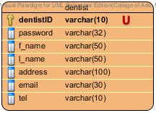

Description

|  |  |  |  |  |  |  |
| --- | --- | --- | --- | --- | --- | --- |
| **Field Name** | **Description** | **Type** | **Length** | **Primary Key** | **Foreign Key** | **Nullable** |
| dentistID | dentistID | varchar | 10 | PK | - | Not Null |
| password | Password of dentist | varchar | 30 | - | - | Not Null |
| f_name | First name of dentist in English | varchar | 50 | - | - | Not Null |
| l_name | Last name of dentist in English | varchar | 50 | - | - | Not Null |
| address | Address of dentist | varchar | 100 | - | - | Not Null |
| tel | Telephone number of dentist | varchar | 30 | - | - | Not Null |
| email | Email of dentist | varchar | 10 | - | - | Not Null |

DB-03: officer

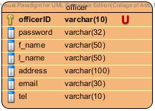

Description

|  |  |  |  |  |  |  |
| --- | --- | --- | --- | --- | --- | --- |
| **Field Name** | **Description** | **Type** | **Length** | **Primary Key** | **Foreign Key** | **Nullable** |
| officerID | officerID | varchar | 10 | PK | - | Not Null |
| password | Password of officer | varchar | 30 | - | - | Not Null |
| f_name | First name of officer in English | varchar | 50 | - | - | Not Null |
| l_name | Last name of officer in English | varchar | 50 | - | - | Not Null |
| address | Address of officer | varchar | 100 | - | - | Not Null |
| tel | Telephone number of officer | varchar | 30 | - | - | Not Null |
| email | Email of officer | varchar | 10 | - | - | Not Null |

DB-04: appointment

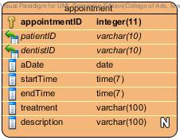

Description

|  |  |  |  |  |  |  |
| --- | --- | --- | --- | --- | --- | --- |
| **Field Name** | **Description** | **Type** | **Length** | **Primary Key** | **Foreign Key** | **Nullable** |
| appointmentID | appointmentID | varchar | 10 | PK | - | Not Null |
| patientID | ID of patient who is in each appointment | varchar | 30 | - | FK | Not Null |
| dentistID | ID of dentist who is in each appointment | varchar | 50 | - | FK | Not Null |
| aDate | Date of an appointment | varchar | 50 | - | - | Not Null |
| startTime | Start time of an appointment | varchar | 100 | - | - | Not Null |
| endTime | End time of an appointment | varchar | 30 | - | - | Not Null |
| treatment | Treatment that going to have | varchar | 10 | - | - | Not Null |
| description | More description of appointment | varchar | 100 | - | - | - |

DB-05: follow up

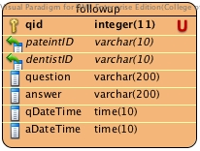

Description

|  |  |  |  |  |  |  |
| --- | --- | --- | --- | --- | --- | --- |
| **Field Name** | **Description** | **Type** | **Length** | **Primary Key** | **Foreign Key** | **Nullable** |
| qid | qid | varchar | 11 | PK | - | Not Null |
| patientID | ID of patient who is in follow up | varchar | 10 | - | FK | Not Null |
| dentistID | ID of dentist who is in each follow up | varchar | 10 | - | FK | Not Null |
| question | Question of the follow up | varchar | 200 | - | - | Not Null |
| answer | Answer of the follow up | varchar | 200 | - | - | Not Null |
| qDateTime | The date of the question in follow up | varchar | 10 | - | - | Not Null |
| aDateTime | The date of the answer in follow up | varchar | 10 | - | - | Not Null |

DB-06: information

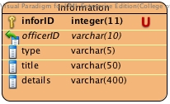

Description

|  |  |  |  |  |  |  |
| --- | --- | --- | --- | --- | --- | --- |
| **Field Name** | **Description** | **Type** | **Length** | **Primary Key** | **Foreign Key** | **Nullable** |
| infoID | qid | integer | 11 | PK | - | Not Null |
| officerID | ID of officer who is add the information | varchar | 10 | - | FK | Not Null |
| type | Type of the information should be information or promotion | varchar | 5 | - | - | Not Null |
| title | Title of the information | varchar | 50 | - | - | Not Null |
| details | Details of the information | varchar | 400 | - | - | Not Null |

DB-07: treatment

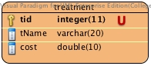

Description

|  |  |  |  |  |  |  |
| --- | --- | --- | --- | --- | --- | --- |
| **Field Name** | **Description** | **Type** | **Length** | **Primary Key** | **Foreign Key** | **Nullable** |
| tid | tid | integer | 11 | PK | - | Not Null |
| tName | tName is the name of the treatment | varchar | 20 | - | - | Not Null |
| cost | Cost of the treatment | varchar | 10 | - | - | Not Null |

DB-08: queue

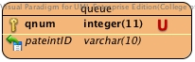

Description

|  |  |  |  |  |  |  |
| --- | --- | --- | --- | --- | --- | --- |
| **Field Name** | **Description** | **Type** | **Length** | **Primary Key** | **Foreign Key** | **Nullable** |
| qnum | qnum | integer | 11 | PK | - | Not Null |
| patientID | patientID who is in the queue | varchar | 10 | - | FK | Not Null |

# Chapter Seven: User Interface Design

## 7. User Interface Design

## 7.1 Web design

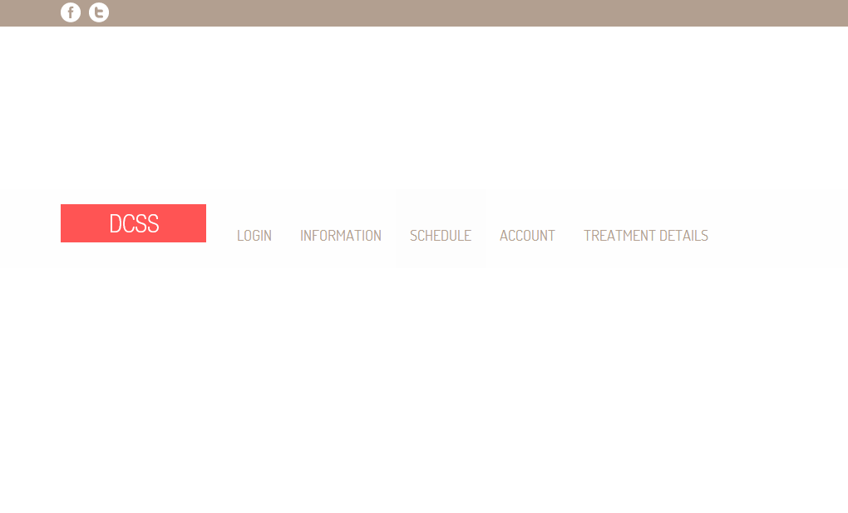

Figure 60: Shows the index page of website[UI-01]

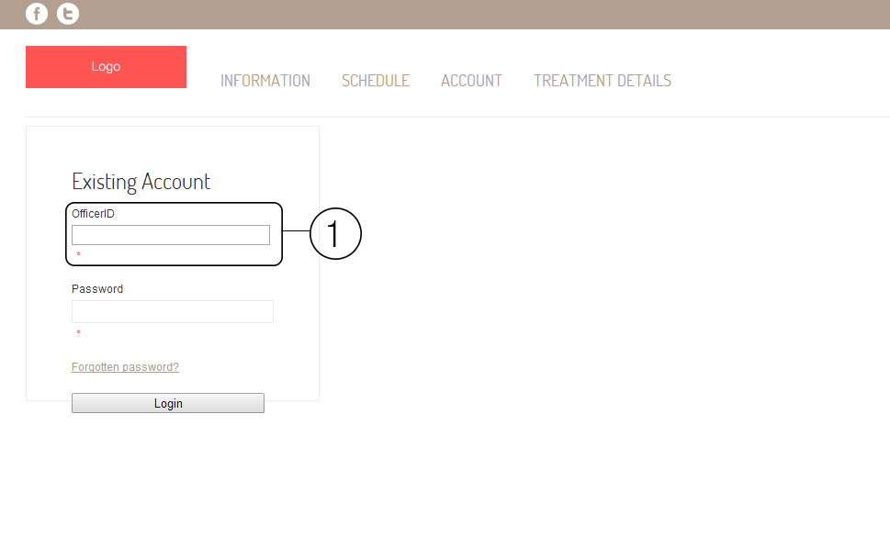

Figure 61: Shows the login page of the website. The area number 1 is the field of input officerID, dentistID and patientID. In officer login page will show as OfficerID, in patient login page will show as PatientID, and in dentist login page will show as DentistID.[UI-02]

**Patient**

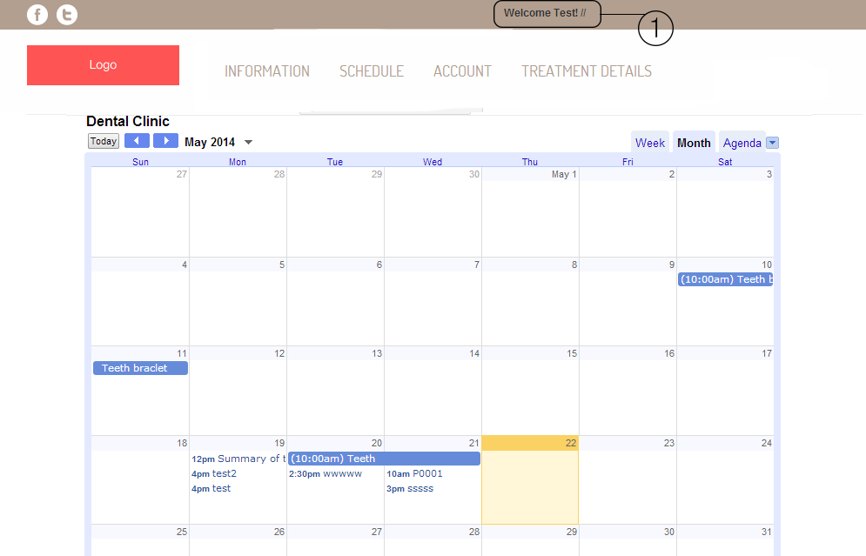

Figure 62: Shows the schedule of dental clinic from google calendar. The area number 1 will shows the name of patient.[UI-03]

**Officer**

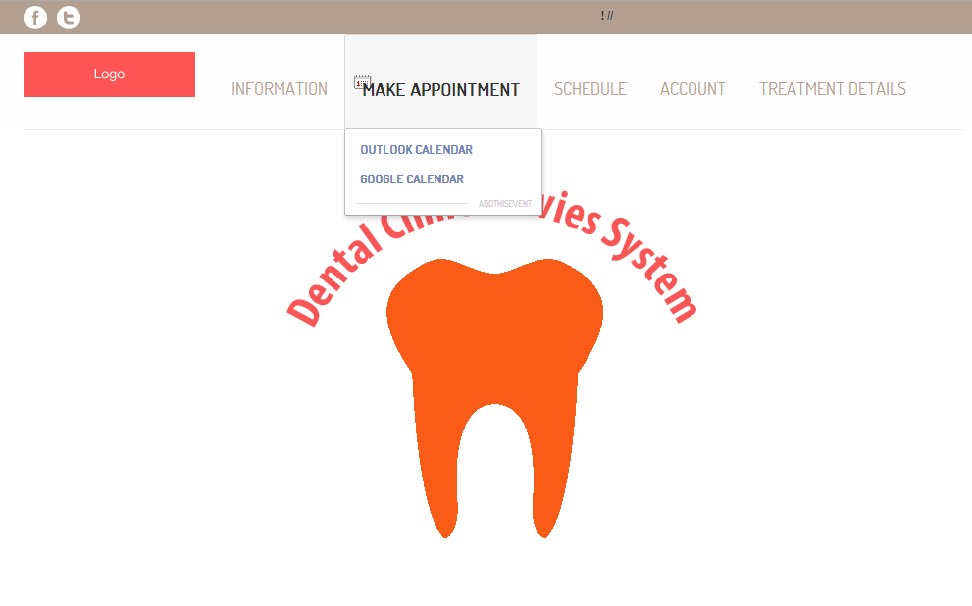

Figure 63: Shows the officer index page after officer login. Officer can make appointment google calendar, view schedule, and manage account.[UI-04]

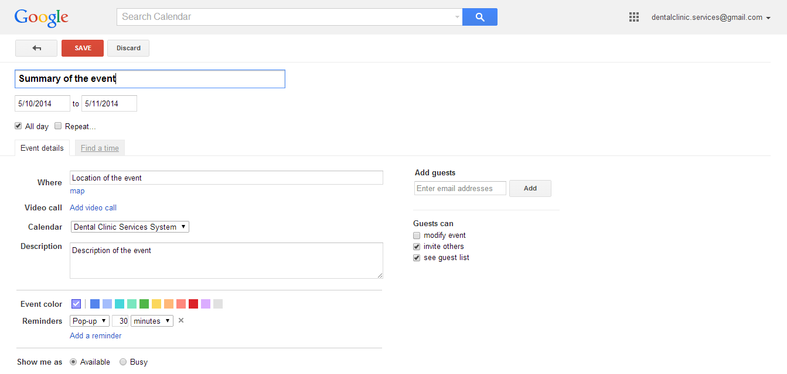

Figure 64: Shows page of google calendar to add the appointment to dental clinic calendar.[UI-05]

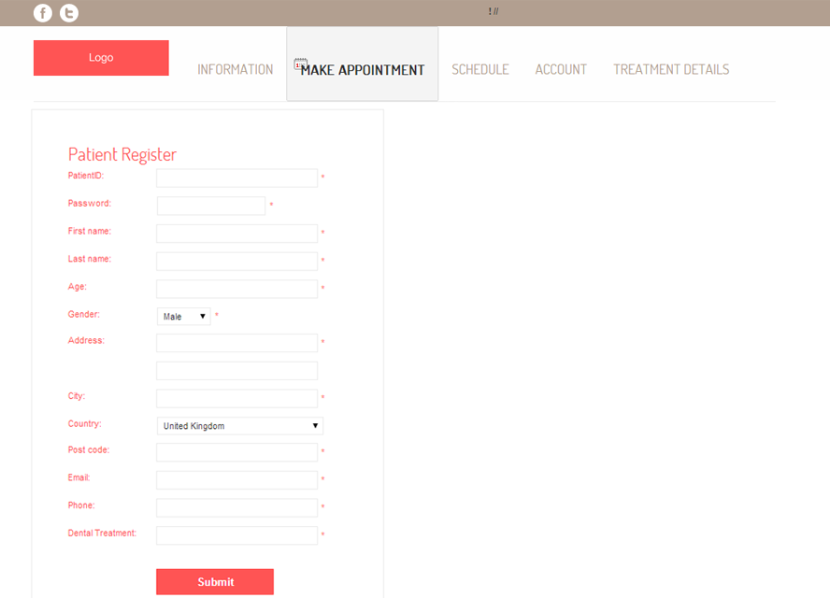

Figure 65: Shows the patient registration page.[UI-06]

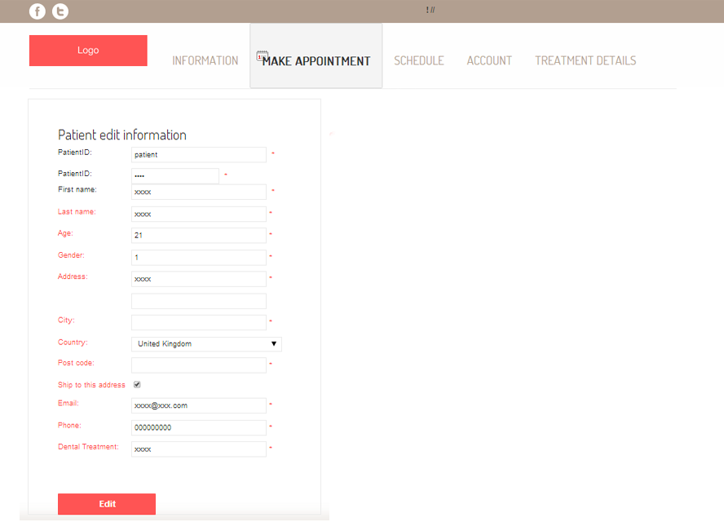

Figure 66: Shows the edit patients’ details page.[UI-07]

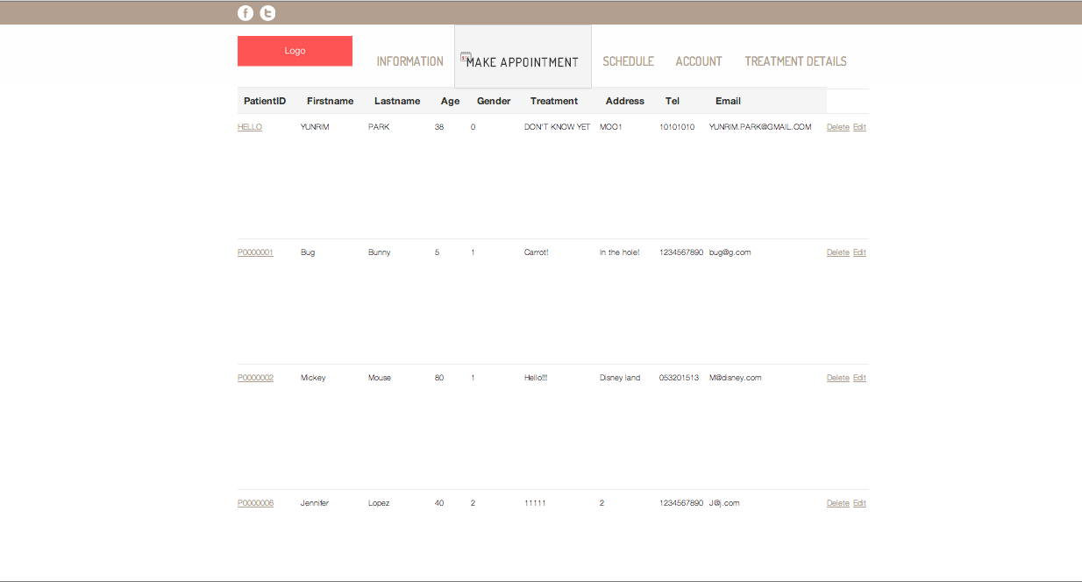

Figure 67: Shows patient list. [UI-08]

Figure 68: Create dentists’ account. [UI-09]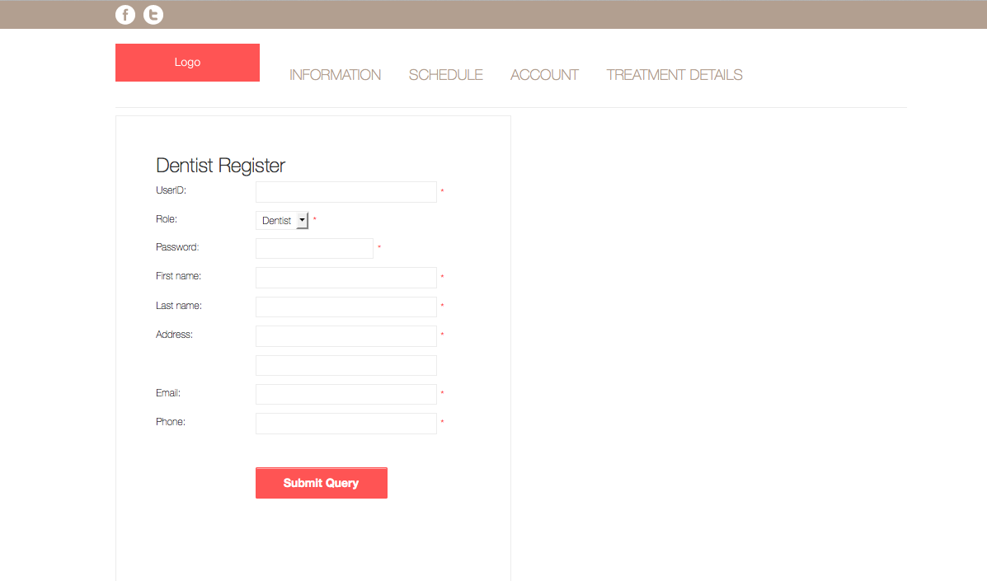

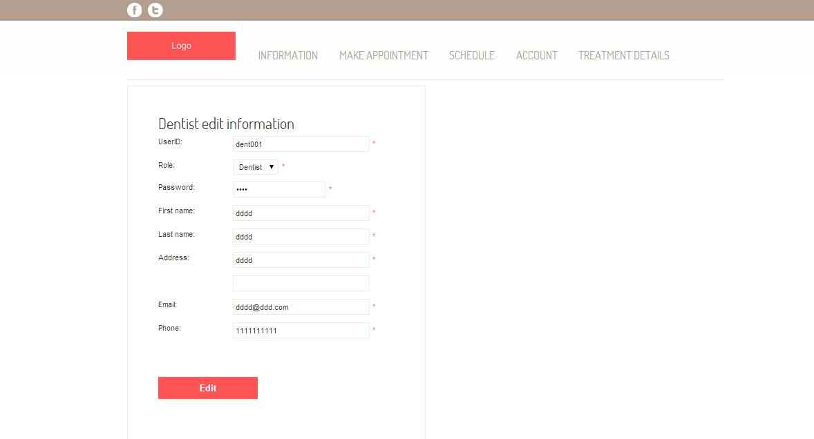Figure 69: Dentist edit information page[UI-10].

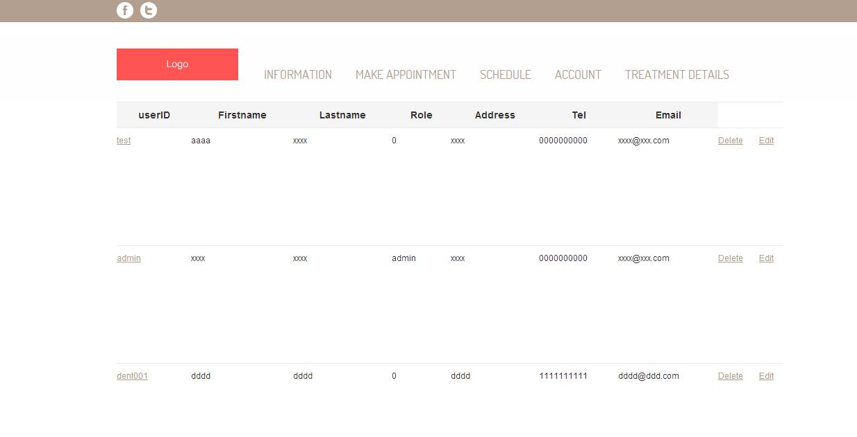

Figure 70: Dentist list page[UI-11].

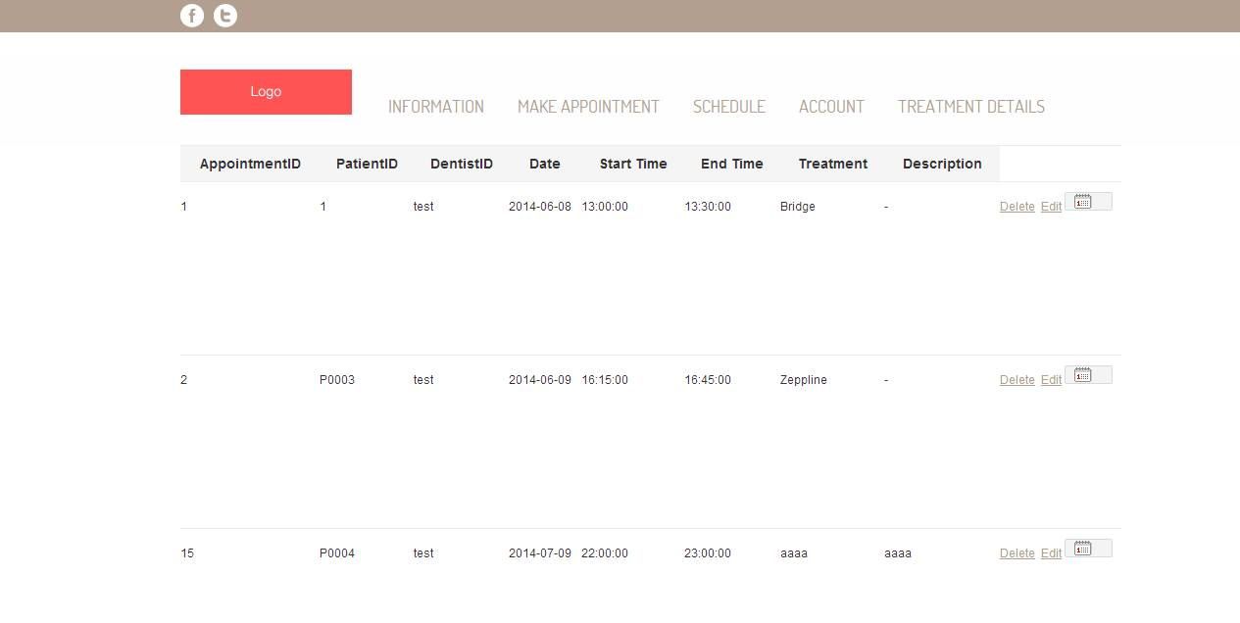

Figure 71: Show appointment list[UI-12].

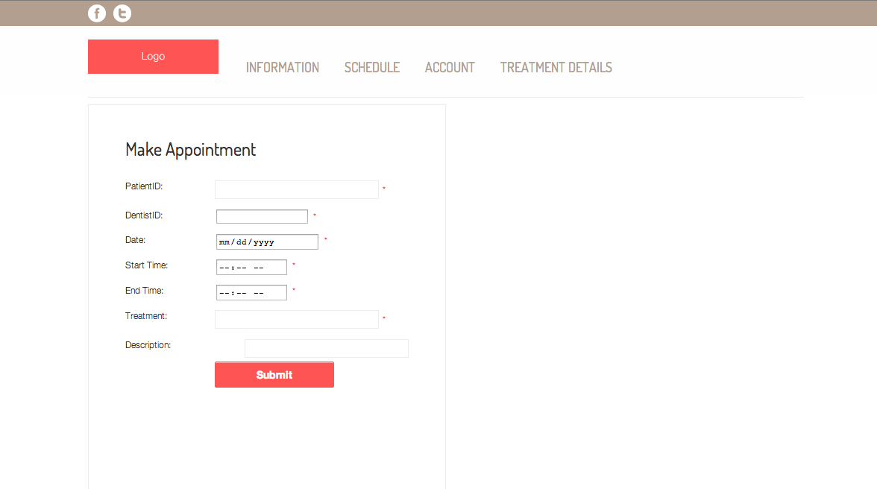

Figure 72: Create appointment page[UI-13].

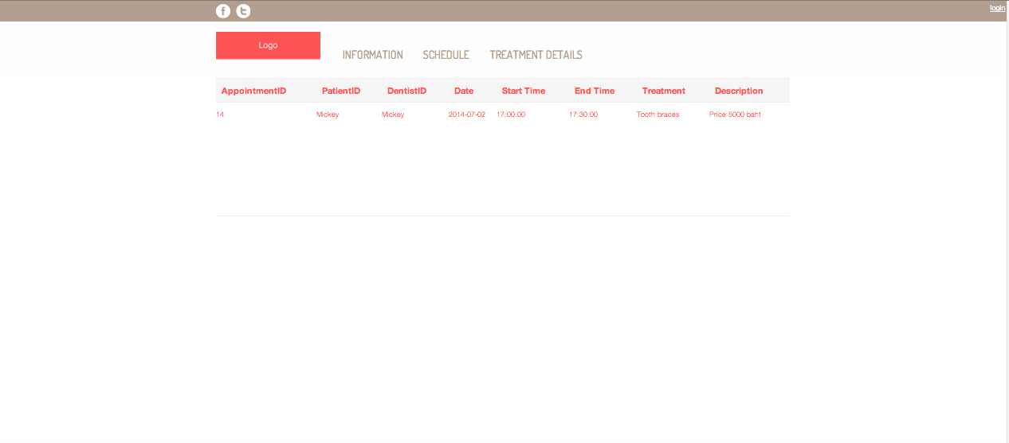

Figure 73: Show patients’ own appointment[UI-14].

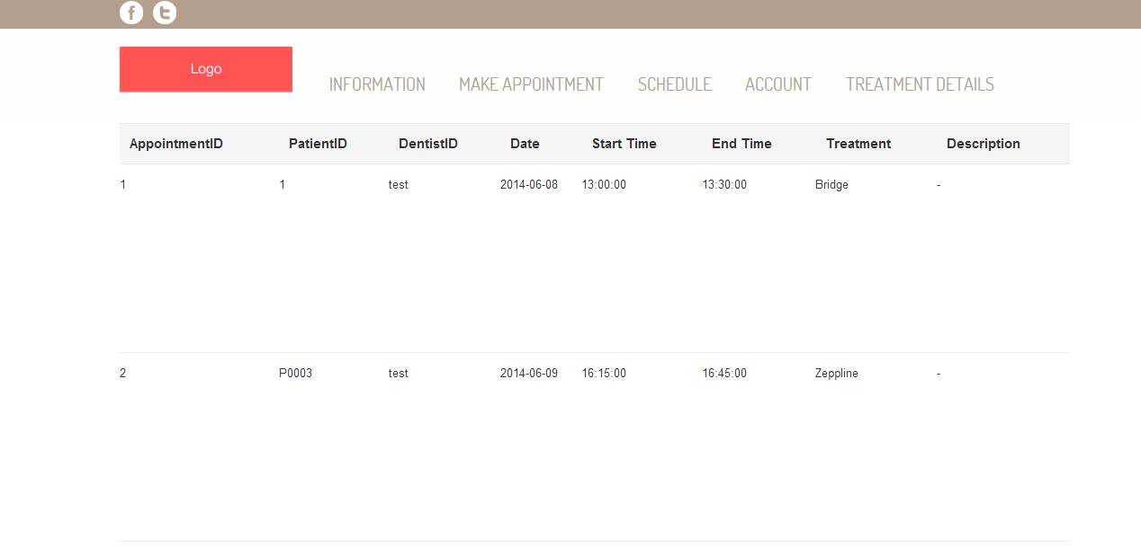

Figure 74: Show dentists’ own appointment[UI-15].

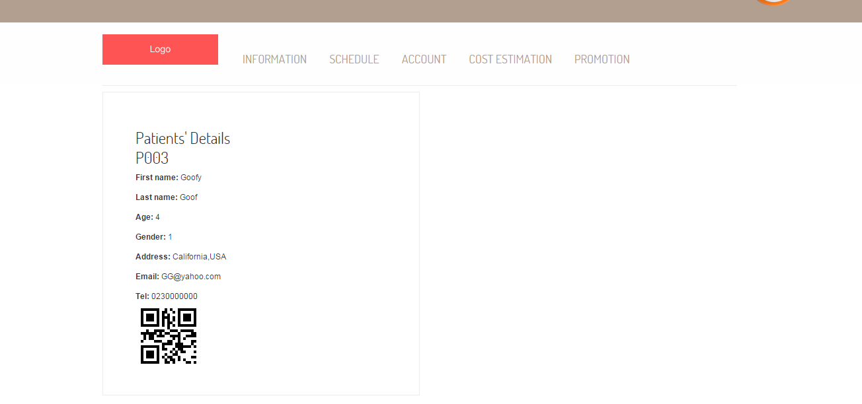

Figure 75: View the QR code and patient’s information in the website [UI-16]

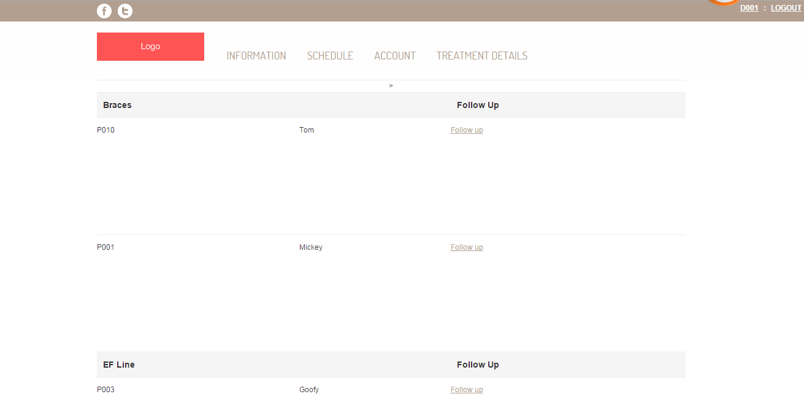

Figure 76: Display patient follow up as a list [UI-17]

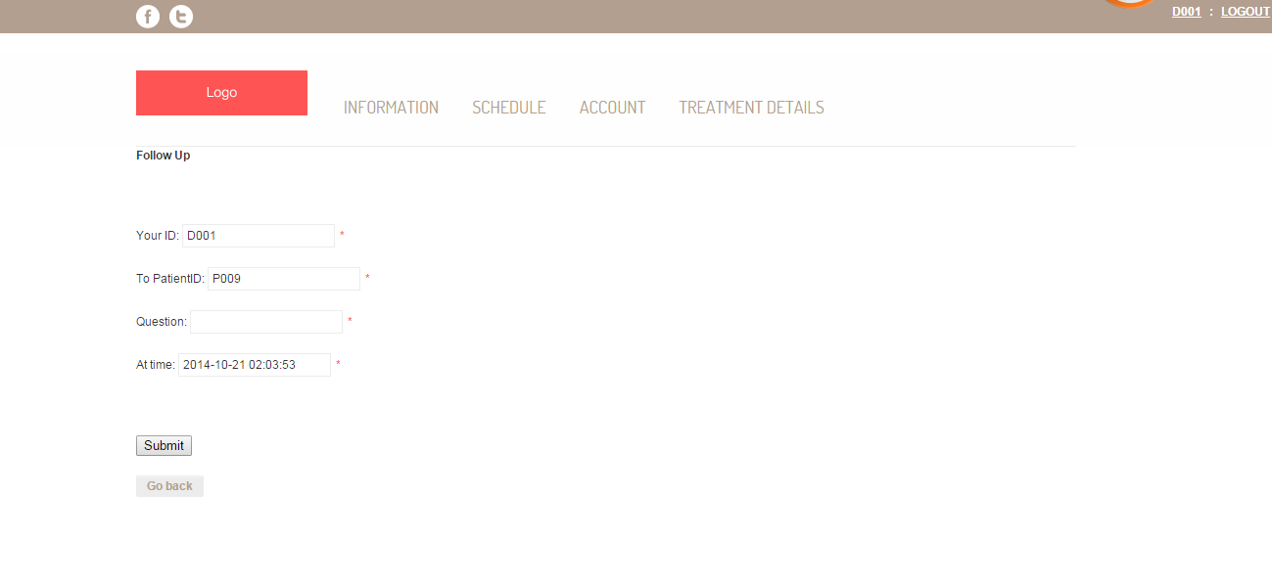

Figure 77: Dentist input the follow up message [UI-18]

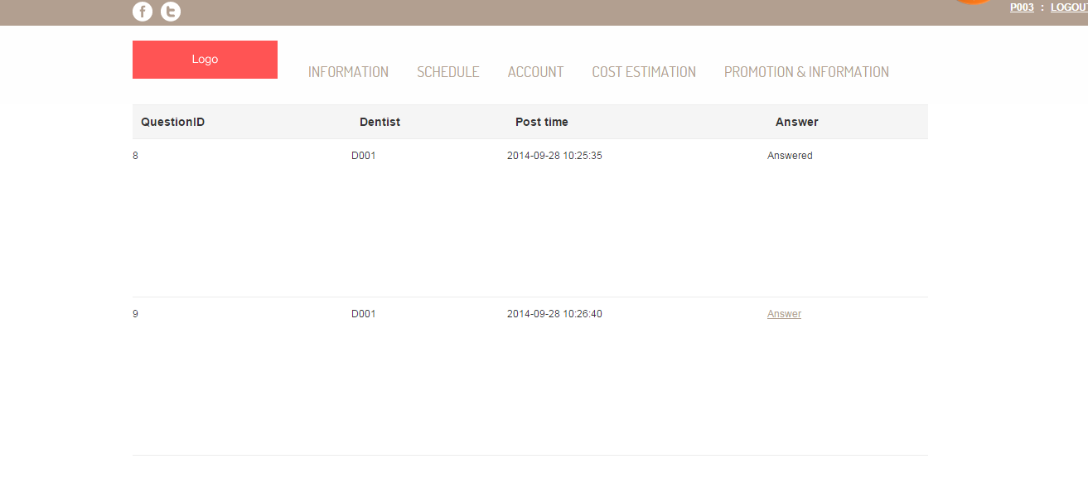

Figure 78: Display dentist’s follow as a list [UI-19]

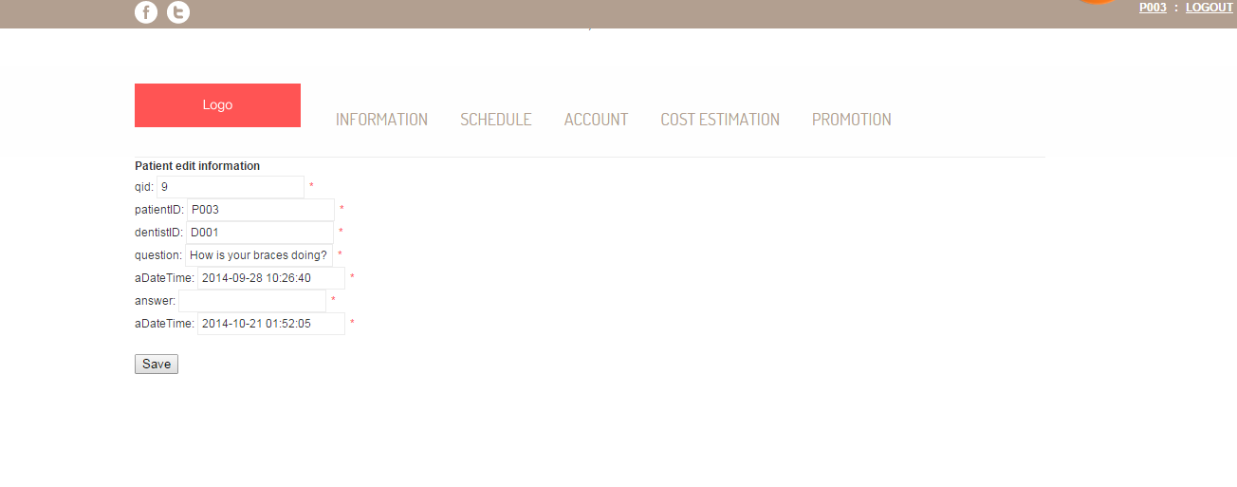

Figure 79: Patient input reply message from dentist follow up [UI-20]

## Figure 80: Officer add patient appointment queue [UI-21]

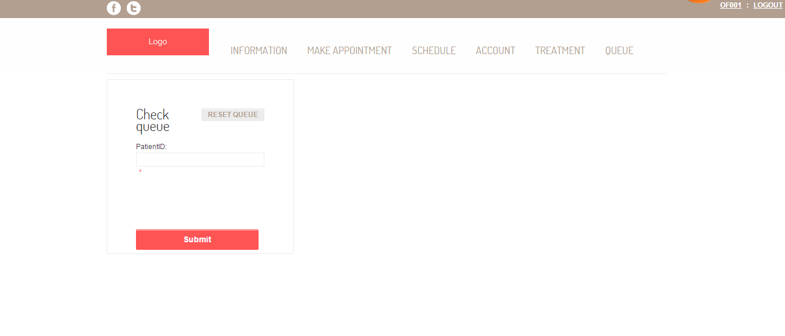

Figure 81: Check patient appointment queue [UI-22]

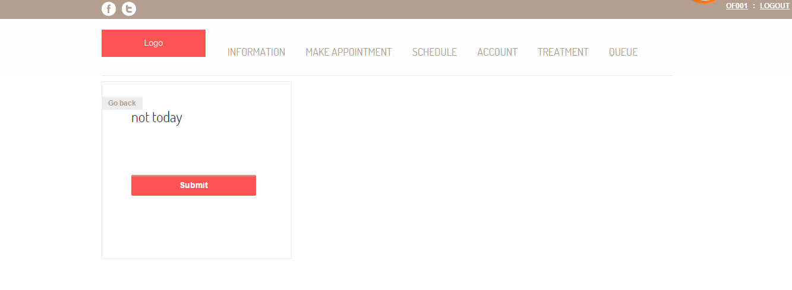

Figure 82: Display patient appointment queue [UI-23]

## Figure 83: Reset patient appointment queue[UI-24]

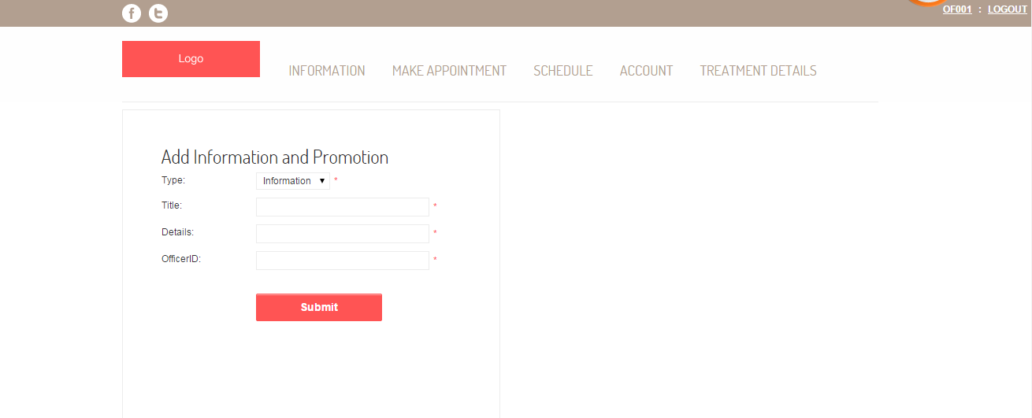

Figure 84: Officer add dental clinic information or promotion [UI-25]

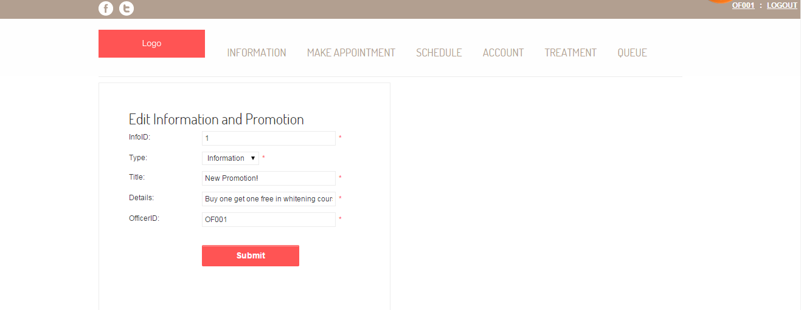

Figure 85: Officer edit dental clinic information or promotion [UI-26]

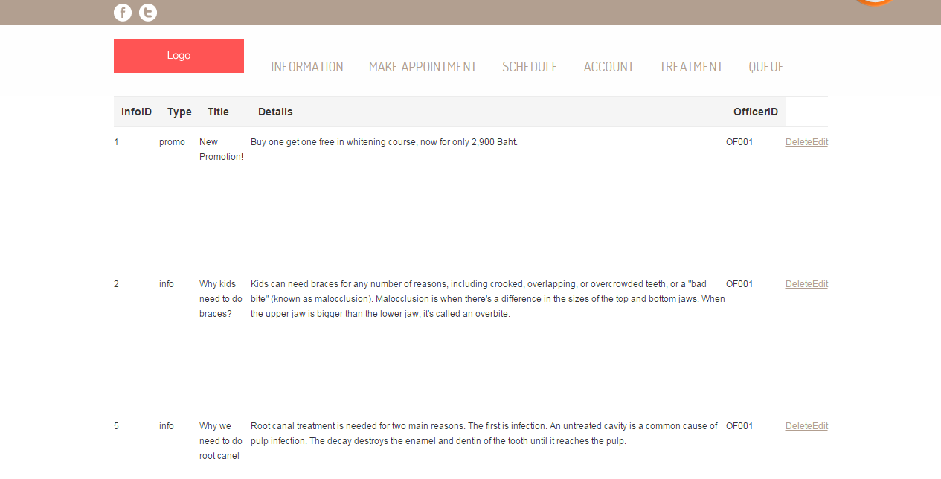

Figure 86: Display all dental clinic information and promotion as a list [UI-27]

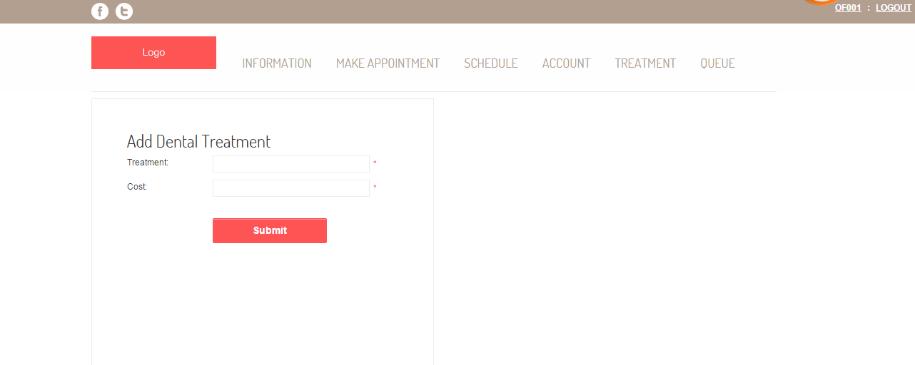

Figure 87: Officer add dental treatment [UI-28]

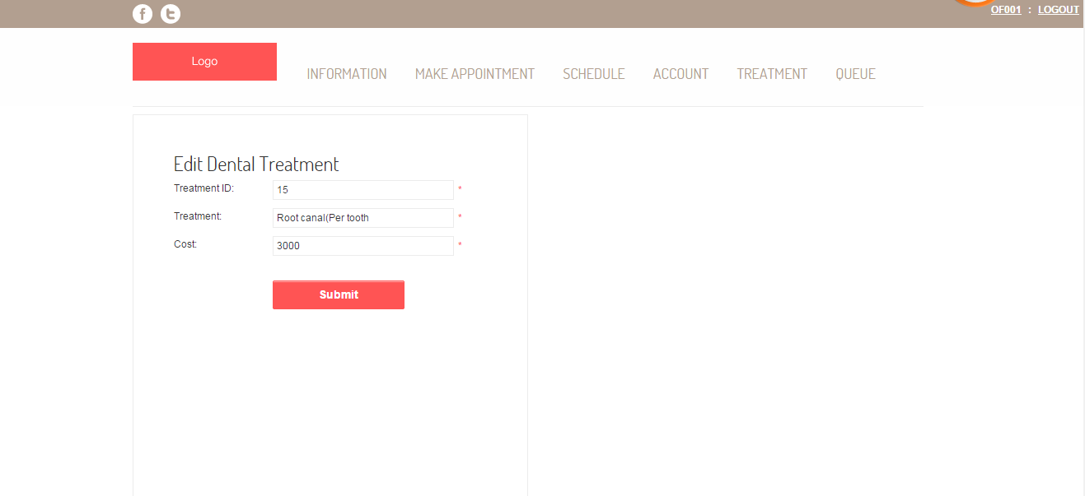

Figure 88: Officer edit dental treatment [UI-29]

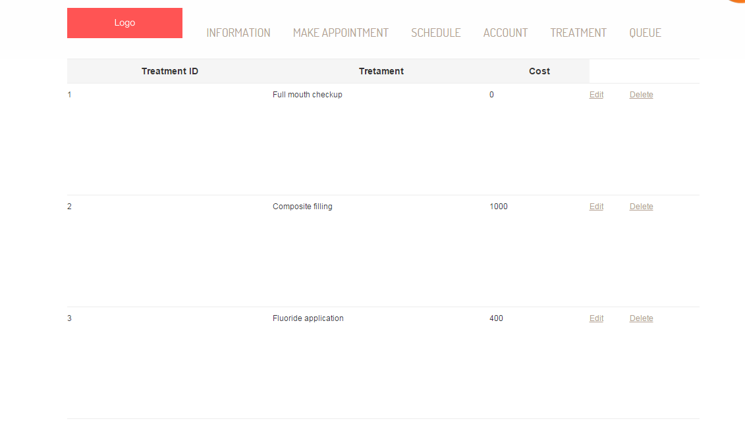

Figure 89: Display all dental treatment as a list[UI-30]

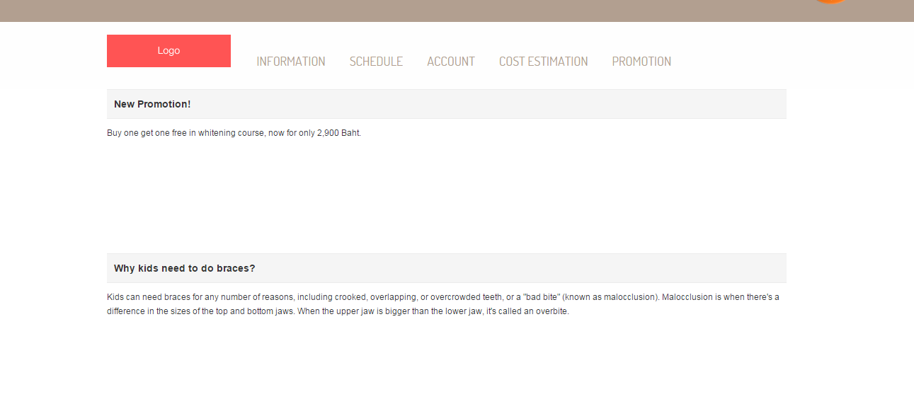

Figure 90: Display information and promotion [UI-31]

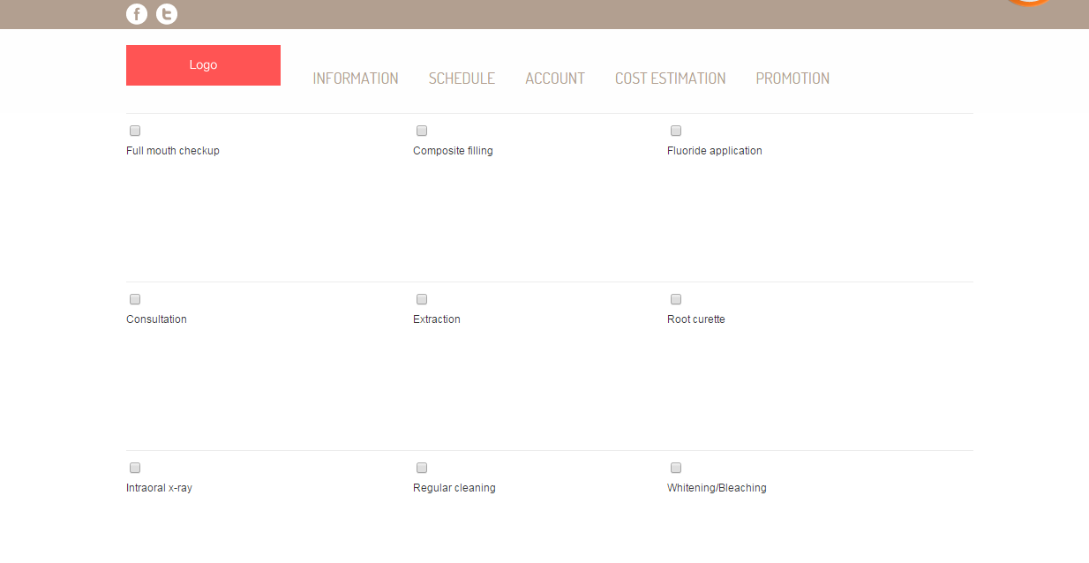

Figure 91: Estimate the dental treatment cost [UI-32]

**6.2Mobile application design**

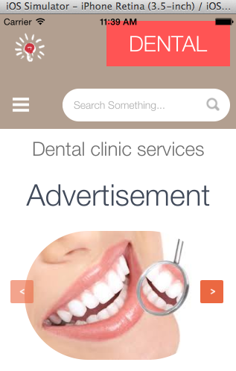

Figure 92: Mobile application index page[UI-33]

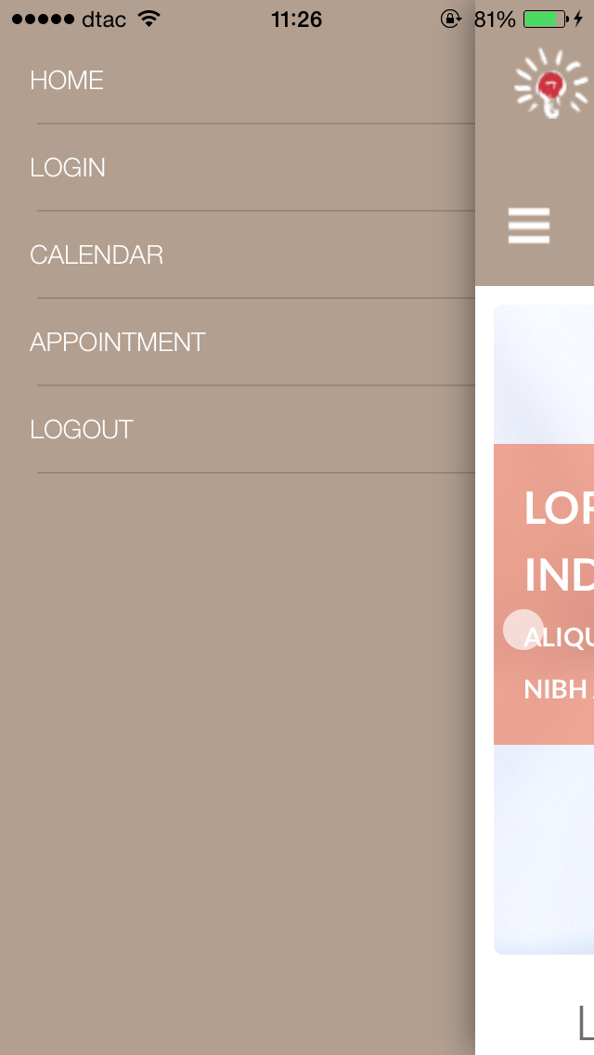

Figure 93: Mobile application menu [UI-34]

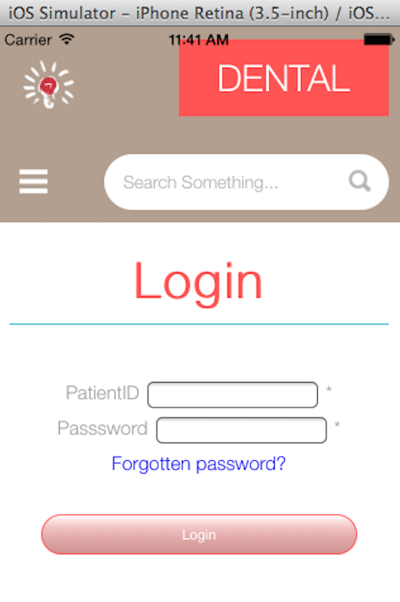

Figure 94: Login page for patient [UI-35]

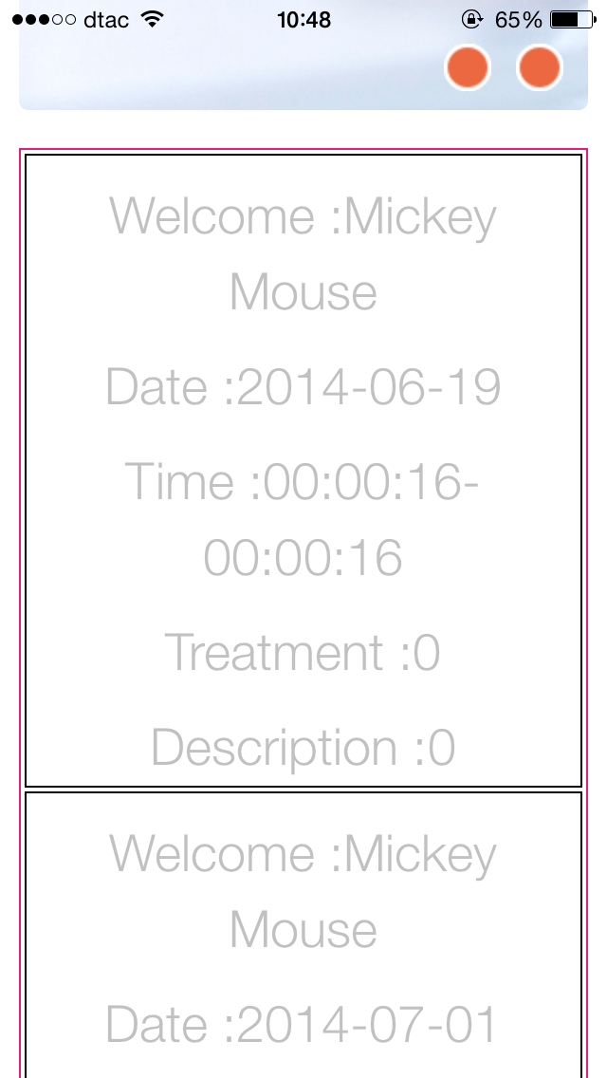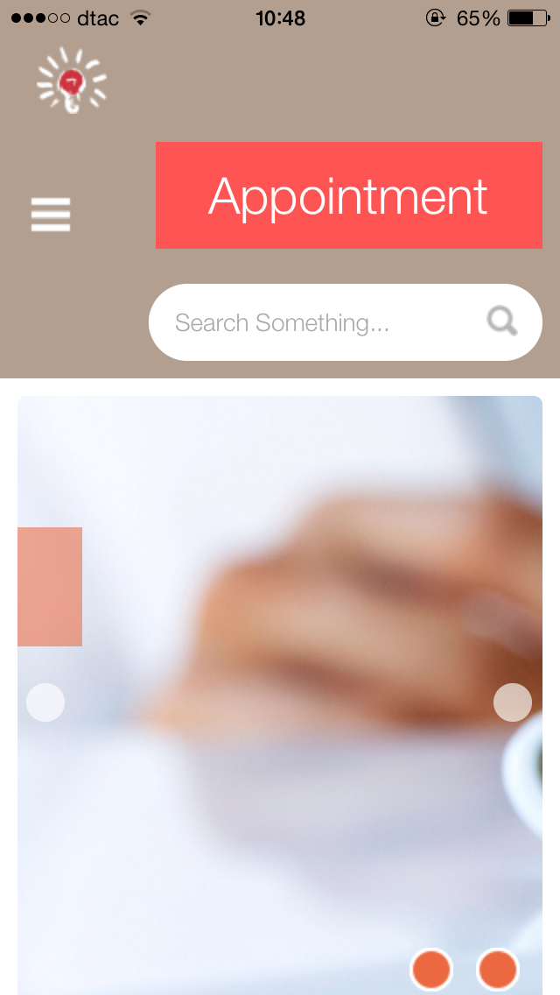

Figure 95: Display patients’ appointment [UI-36]

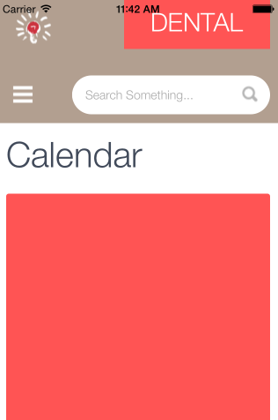

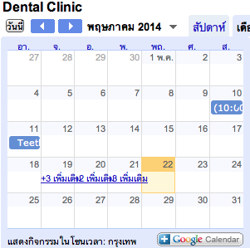

Figure 96: Dental clinic calendar [UI-37]

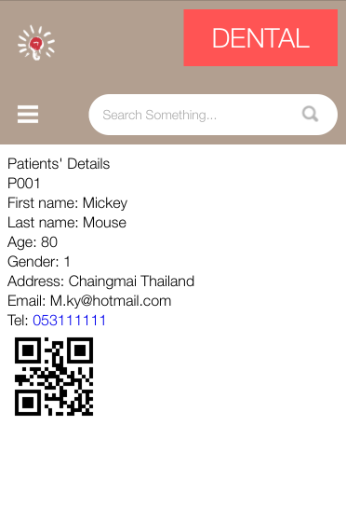

Figure 97: View the QR code and patient’s information in mobile application [UI-38]

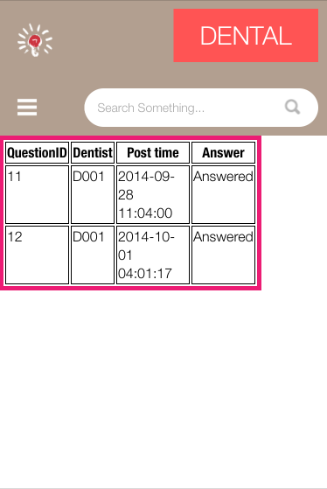

Figure 98: View dentist follow up message in mobile application[UI-39]

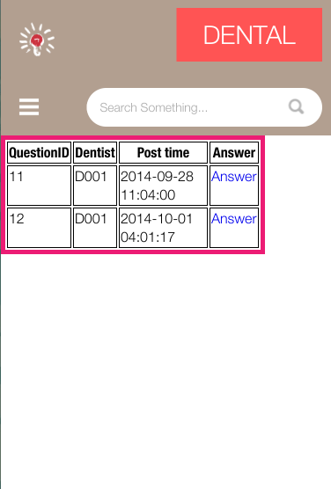

Figure 99: Selects the dentist message to answer[UI-40]

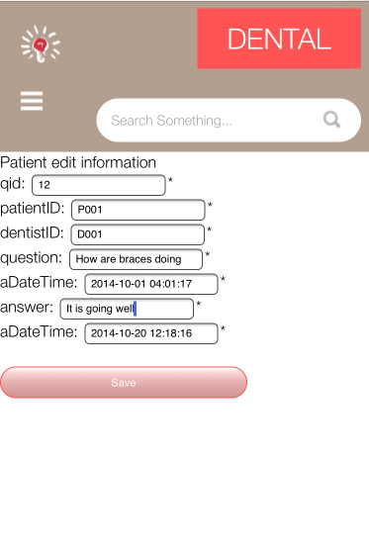

Figure 100: Input answer into the follow up form [UI-41]

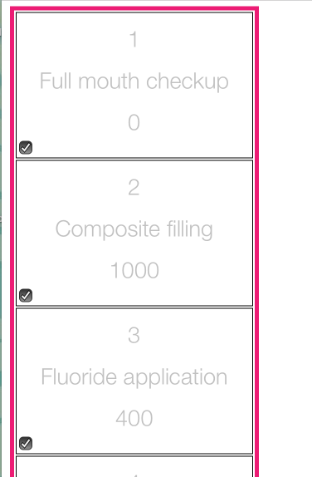

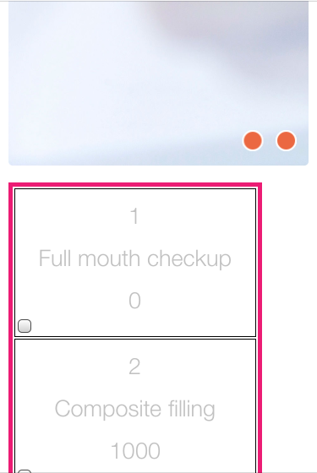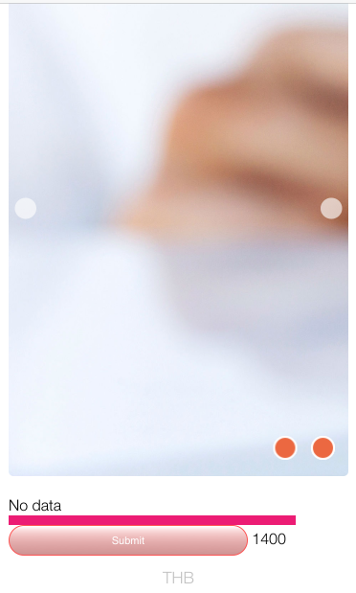

Figure 101: Estimate the dental treatment cost[UI-42]

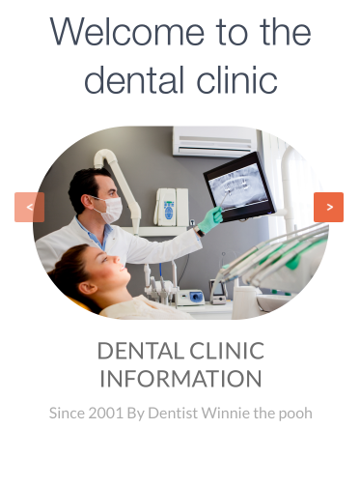

Figure 102: View the dental clinic information and promotion [UI-43]